ANALYSIS OF REALTIME SALES DATA GENERATED USING WEB APPLICATION

A project report submitted for the partial fulfilment for the award of Degree of

MASTER OF COMPUTER APPLICATIONS

SUBMITTED BY

NARESH KUMAR J

(Reg. No. 1713103037106)

Under the guidance of

Dr. T. SANTHANAM, M.Sc., Ph.D, P.G.D.C.A

Head of the Department

PG and Research Department of Computer Science and Applications.



DWARAKA DOSS GOVERDHAN DOSS VAISHNAV COLLEGE (AUTONOMOUS)

ARUMBAKKAM, CHENNAI - 600 106

JUNE 2020

DWARAKA DOSS GOVERDHAN DOSS VAISHNAV COLLEGE

(AUTONOMOUS)

ARUMBAKKAM, CHENNAI-600 106.

PG AND RESEARCH DEPARTMENT OF COMPUTER SCIENCE

AND APPLICATIONS

BONAFIDE CERTIFICATE

This is to certify that this project work entitled “ANALYSIS OF REALTIME SALES DATA GENERATED USING WEB APPLICATION” is a bonafide record done by NARESH KUMAR J (Reg. No. 1713103037106) in partial fulfilment for award of Degree of Master of Computer Applications under our guidance and supervision, during the academic year 2019-2020.

Project Guide Head of the Department

Submitted for the Viva-Voce Examination held on .......................................... at Dwaraka Doss Goverdhan Doss Vaishnav College, Chennai-600106.

Internal Examiner External Examiner

ACKNOWLEDGEMENT

I take this opportunity to express my sincere thanks to everyone in guiding me to complete this project. I thank the almighty for the blessing that have been showered upon me to complete the project successfully.

I express my sincere thanks to Dr. R. Ganesan, M.Com., M.Phil., Ph.D., Principal, Dwaraka Doss Goverdhan Doss Vaishnav College for providing me an opportunity to do my project work.

My sincere thanks to the Head of the PG Department of Computer Science and Applications, DR. T. Santhanam, M.Sc., Ph.D., PGDCA, for his continued support and help in compiling the project.

I acknowledge my gratitude to my guide Dr. T. SANTHANAM, M.Sc., Ph.D., PGDCA., for his help and valuable guidelines for the successful completion of this project on entitled “ANALYSIS OF REALTIME SALES DATA GENERATED USING WEB APPLICATION”.

My special thanks to all faculty members and staff members of PG Department of Computer Science and Applications for their support and encouragement for the successful completion of the project.

I also thank my friends for providing moral support and timely help to finish the project.

I whole heartedly express my sincere thanks to my lovable parents and relatives who encouraged me with the moral and economic support.

NARESH KUMAR J

|  |  |  |  |
| --- | --- | --- | --- |
| S.NO | |  | | --- | | CONTENT | | PAGE NO. |
| 1  2  3    4    5 | ABSTRACT  INTRODUCTION:  1.1 Objective  1.3 Overview  SYSTEM SPECIFICATION:  2.1 Hardware Specification  2.2 Software Specification  2.3 Programming Language  2.4 Technologies Used  2.5 Operating System    DEVELOPMENT ENVIRONMENT:  3.1 Python  3.2 Django  3.3 Java Script  3.4 SQL  3.5 Html  3.6 AWS  3.7 Bootstrap  3.8 Heroku  APPENDIX:  4.1 Source Code  4.2 Output  CONCLUSION:  5.1 Summary  5.2 Future work  5.3 Reference | 1  2    4  5  23  97 |

ABSTRACT

Ecommerce is a shortened version of the phrase “electronic commerce” which essentially describes any type of exchange of currency for goods or services online. Ecommerce is a term that covers everything there is to do with buying or selling online, and can sometimes be otherwise written as “E Commerce,” “e-commerce,” or “eCommerce.” It describes the act of performing business via the internet. Since the definition of ecommerce is so open-ended it literally includes any type of buying or selling of goods or services online there are so many different types of ecommerce businesses that exist. Every ecommerce business can be differentiated by the types of products that it sells. There are four main products that any ecommerce business can sell and they are: Physical Products, Digital Products, Services, Affiliates. Every single ecommerce business online can fit into one or more of these categories, and this basically just tells you what type of products they sell to their customers. The customers can buy and consume the product if it is a physical product it will either be directly or indirectly be delivered to the customer in case of digital product or services either a direct access or a access key will be provided to the customer to keep it confidential and to use it. The Nashkart web application was also created in a motive to develop it further for the business use in the future if there is a need. But for the presence it is a model of what it is going to be like in the near future with very few functionalities and imaginary products. The analysis on this particular type of data is generally used to know what happened in the business especially in the past. With the help of the results from the analysis business can be expanded or developed and to know the strength and weakness of the sales. Analysing the data is very import key factor for a business in this digital world. As data plays a vital role now and in future, analysing and getting a meaningful information from its raw form is necessary.

1. INTRODUCTION

Nashkart was developed to get the sales data for analysis as part of project. When I decided to do an Analysis of sales data instead of getting data from some other source I created my own web application to generate real time data.

OBJECTIVE:

The objective is to analyse and get insight of data collected from ecommerce web application (Nashkart). The ecommerce web application is developed using Django the data collected is then pre-processed and analysed using python. The visualization used are done using Tableau. This analysis will be used to get insight and increase the sales of ecommerce web application.

OVERVIEW:

Nashkart is a web application created using Django framework. Django is a Python-based free and open-source web framework that follows the model-template-view (MVC) architectural pattern.t is maintained by the Django Software Foundation (DSF), an American independent organization established as a non-profit. Django's primary goal is to ease the creation of complex, database-driven websites. The framework emphasizes reusability and "pluggability" of components, less code, low coupling, rapid development, and the principle of don't repeat yourself. Python is used throughout, even for settings files and data models. Django also provides an optional administrative create, read, update and delete interface that is generated dynamically through introspection and configured via admin models.

The data collected from the user and are stored in cloud. The cloud database used is AWS(RDS). Amazon Relational Database Service (or Amazon RDS) is a distributed relational database service by Amazon Web Services (AWS).It is a web service running "in the cloud" designed to simplify the setup, operation, and scaling of a relational database for use in applications. Administration processes like patching the database software, backing up databases and enabling point-in-time recovery are managed automatically. Scaling storage and compute resources can be performed by a single API call as AWS does not offer an connection to RDS instances.

This RDS used is MySQL. MySQL is an open-source relational database management system (RDBMS). "SQL", the abbreviation for Structured Query Language. MySQL is free and open-source software under the terms of the GNU General Public License, and is also available under a variety of proprietary licenses. MySQL was owned and sponsored by the Swedish company MySQL AB, which was bought by Sun Microsystems (now Oracle Corporation). In 2010, when Oracle acquired Sun, Widenius forked the open-source MySQL project to create MariaDB. MySQL is a component of the LAMP web application software stack (and others), which is an acronym for Linux, Apache, MySQL, Perl/PHP/Python. MySQL is used by many database-driven web applications, including Drupal, Joomla, phpBB, and WordPress.

The cloud database is connected to the local server using MYSQL workbench. The web application is deployed online using Heroku . Heroku is a cloud platform as a service (PaaS) supporting several programming languages. One of the first cloud platforms, Heroku has been in development since June 2007, when it supported only the Ruby programming language, but now supports Java, Node.js, Scala, Clojure, Python, PHP, and Go. For this reason, Heroku is said to be a polyglot platform as it has features for a developer to build, run and scale applications in a similar manner across most languages.

Deployment is made through Heroku ULI and GitHub. Analysis of the collected data is done using Python. Python is a general-purpose interpreted, interactive, object-oriented, and high-level programming language. An interpreted language, Python has a design philosophy that emphasizes code readability (notably using whitespace indentation to delimit code blocks rather than curly brackets or keywords), and a syntax that allows programmers to express concepts in fewer lines of code than might be used in languages such as C++or Java. It provides constructs that enable clear programming on both small and large scales. Python interpreters are available for many operating systems. CPython, the reference implementation of Python, is open source software and has a community-based development model, as do nearly all of its variant implementations. CPython is managed by the non-profit Python Software Foundation. Python features a dynamic type system and automatic memory management. It supports multiple programming paradigms, including object-oriented, imperative, functional and procedural, and has a large and comprehensive standard library.

1. REQUIREMENT SPECIFICATION:

Technologies used:

1. Django

2. AWS

3. Heroku

4. Tableau

Programming language:

1. Python

2. Java Script

Database used:

1. MySQL

Software Requirements:

For developing the application the following are the Software used:

1. Visual Studio Code

2. MySQL Workbench

3. Spyder

4. Tableau Desktop

Operating Systems support:

1. Windows 8

2. Windows 10

Hardware Requirements:

For developing the application the following are the Hardware Requirements:

1. Processor: Intel(R) Core(TM) i5-8250U CPU @1.60Hz 1.80 GHz

2. RAM: 8GB

3. System Type: 64-bit Operating System, x64-based processor

3. DEVELOPMENT ENVIRONMENT

PYTHON:

Python is a general-purpose interpreted, interactive, object-oriented, and high-level programming language. An interpreted language, Python has a design philosophy that emphasizes code readability (notably using whitespace indentation to delimit code blocks rather than curly brackets or keywords), and a syntax that allows programmers to express concepts in fewer lines of code than might be used in languages such as C++or Java. It provides constructs that enable clear programming on both small and large scales. Python interpreters are available for many operating systems. CPython, the reference implementation of Python, is open source software and has a community-based development model, as do nearly all of its variant implementations. CPython is managed by the non-profit Python Software Foundation. Python features a dynamic type system and automatic memory management. It supports multiple programming paradigms, including object-oriented, imperative, functional and procedural, and has a large and comprehensive standard library

Python is a multi-paradigm programming language. Object-oriented programming and structured programming are fully supported, and many of its features support functional programming and aspect-oriented programming (including by metaprogramming and metaobjects (magic methods)) Many other paradigms are supported via extensions, including design by contract and logic programming. Python uses dynamic typing and a combination of reference counting and a cycle-detecting garbage collector for memory management. It also features dynamic name resolution (late binding), which binds method and variable names during program execution.

Python's design offers some support for functional programming in the Lisp tradition. It has filter, map, and reduce functions; list comprehensions, dictionaries, sets, and generator expressions. The standard library has two modules (Itertools and Functools) that implement functional tools borrowed from Haskell and Standard ML. The language's core philosophy is summarized in the document The Zen of Python (PEP 20), which includes aphorisms such as:

Beautiful is better than ugly.

Explicit is better than implicit.

Simple is better than complex.

Complex is better than complicated.

Readability counts.

Rather than having all of its functionality built into its core, Python was designed to be highly extensible. This compact modularity has made it particularly popular as a means of adding programmable interfaces to existing applications. Van Rossum's vision of a small core language with a large standard library and easily extensible interpreter stemmed from his frustrations with ABC, which espoused the opposite approach. Python strives for a simpler, less-cluttered syntax and grammar while giving developers a choice in their coding methodology. In contrast to Perl's "there is more than one way to do it" motto, Python embraces a "there should be one—and preferably only one—obvious way to do it" design philosophy. Alex Martelli, a Fellow at the Python Software Foundation and Python book author, writes that "To describe something as 'clever' is not considered a compliment in the Python culture." Python's developers strive to avoid premature optimization, and reject patches to non-critical parts of the CPython reference implementation that would offer marginal increases in speed at the cost of clarity. When speed is important, a Python programmer can move time-critical functions to extension modules written in languages such as C, or use PyPy, a just-in-time compiler. CPython is also available, which translates a Python script into C and makes direct C-level API calls into the Python interpreter. An important goal of Python's developers is keeping it fun to use. This is reflected in the language's name—a tribute to the British comedy group Monty Python and in occasionally playful approaches to tutorials and reference materials, such as examples that refer to spam and eggs instead of the standard foo and bar. A common neologism in the Python community is pythonic, which can have a wide range of meanings related to program style. To say that code is pythonic is to say that it uses Python idioms well, that it is natural or shows fluency in the language, that it conforms with Python's minimalist philosophy and emphasis on readability. In contrast, code that is difficult to understand or reads like a rough transcription from another programming language is called unpythonic. Users and admirers of Python, especially those considered knowledgeable or experienced, are often referred to as Pythonistas

DJANGO:

Django is a Python-based free and open-source web framework that follows the model-template-view (MVC) architectural pattern.t is maintained by the Django Software Foundation (DSF), an American independent organization established as a non-profit. Django's primary goal is to ease the creation of complex, database-driven websites. The framework emphasizes reusability and "pluggability" of components, less code, low coupling, rapid development, and the principle of don't repeat yourself. Python is used throughout, even for settings files and data models. Django also provides an optional administrative create, read, update and delete interface that is generated dynamically through introspection and configured via admin models.

Components

Despite having its own nomenclature, such as naming the callable objects generating the HTTP responses "views", the core Django framework can be seen as an MVC architecture. It consists of an object-relational mapper (ORM) that mediates between data models (defined as Python classes) and a relational database ("Model"), a system for processing HTTP requests with a web templating system ("View"), and a regular-expression-based URL dispatcher ("Controller").

Also included in the core framework are:

A lightweight and standalone web server for development and testing, a form serialization and validation system that can translate between HTML forms and values suitable for storage in the database, a template system that utilizes the concept of inheritance borrowed from object-oriented programming, a caching framework that can use any of several cache methods, support for middleware classes that can intervene at various stages of request processing and carry out custom functions, an internal dispatcher system that allows components of an application to communicate events to each other via pre-defined signals, an internationalization system, including translations of

Django's own components into a variety of languages, a serialization system that can produce and read XML and/or JSON representations of Django model instances, a system for extending the capabilities of the template engine, an interface to Python's built-in unit test framework, Django REST framework is a powerful and flexible toolkit for building Web APIs.

Development tools with Django support

For developing a Django project, no special tools are necessary, since the source code can be edited with any conventional text editor. Nevertheless, editors specialized on computer programming can help increase the productivity of development, e.g., with features such as syntax highlighting. Since Django is written in Python, text editors which are aware of Python syntax are beneficial in this regard. Integrated development environments (IDE) add further functionality, such as debugging, refactoring, and unit testing. As with plain editors, IDEs with support for Python can be beneficial. Some IDEs that are specialized on Python additionally have integrated support for Django projects, so that using such an IDE when developing a Django project can help further increase productivity. For comparison of such Python IDE.

Django is a high-level Python Web framework that encourages rapid development and clean, pragmatic design. Built by experienced developers, it takes care of much of the hassle of Web development, so you can focus on writing your app without needing to reinvent the wheel. It’s free and open source. Django's primary goal is to ease the creation of complex, database-driven websites. Django emphasizes reusability and "pluggability" of components, rapid development, and the principle of don't repeat yourself. Python is used throughout, even for settings files and data models.



Django also provides an optional administrative [create, read, update and delete](https://en.wikipedia.org/wiki/Create,_read,_update_and_delete) interface that is generated dynamically through [introspection](https://en.wikipedia.org/wiki/Introspection_(computer_science)) and configured via admin models.

~~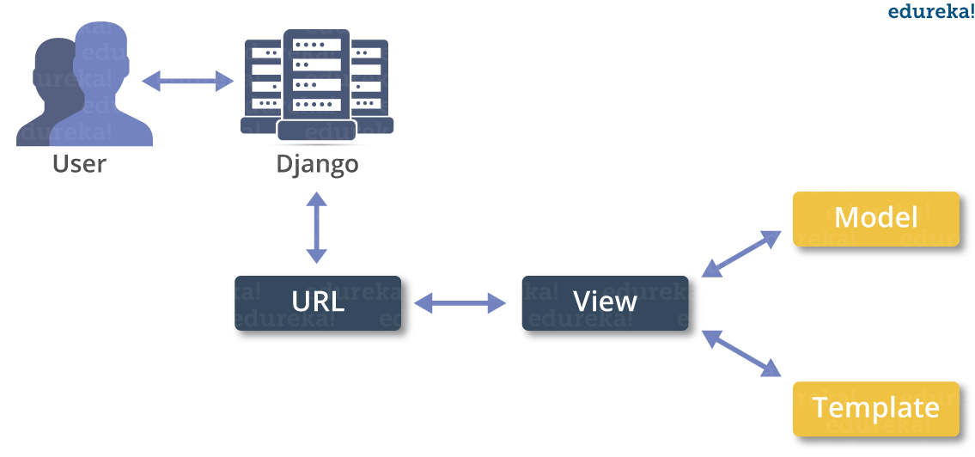~~

JAVASCRIPT:

JavaScript often abbreviated as JS, is a programming language that conforms to the ECMAScript specification. JavaScript is high-level, often just-in-time compiled, and multi-paradigm. It has curly-bracket syntax, dynamic typing, prototype-based object-orientation, and first-class functions. Alongside HTML and CSS, JavaScript is one of the core technologies of the World Wide Web. JavaScript enables interactive web pages and is an essential part of web applications. The vast majority of websites use it for client-side page behavior, and all major web browsers have a dedicated JavaScript engine to execute it. As a multi-paradigm language, JavaScript supports event-driven, functional, and imperative programming styles. It has application programming interfaces (APIs) for working with text, dates, regular expressions, standard data structures, and the Document Object Model (DOM). However, the language itself does not include any input/output (I/O), such as networking, storage, or graphics facilities, as the host environment (usually a web browser) provides those APIs. JavaScript engines were originally used only in web browsers, but they are now embedded in some servers, usually via Node.js. They are also embedded in a variety of applications created with frameworks such as Electron and Cordova. Although there are similarities between JavaScript and Java, including language name, syntax, and respective standard libraries, the two languages are distinct and differ greatly in design.

Development tools:

Important tools have evolved with the language. Every major web browser has built-in web development tools, including a JavaScript debugger. Static program analysis tools, such as ESLint and JSLint, scan JavaScript code for conformance to a set of standards and guidelines. Some browsers have built-in profilers. Stand-alone profiling libraries have also been created, such as benchmark.js and jsbench. Many text editors have syntax highlighting support for JavaScript code

Cross-site vulnerabilities:

A common JavaScript-related security problem is cross-site scripting (XSS), a violation of the same-origin policy. XSS vulnerabilities occur when an attacker is able to cause a target Web site, such as an online banking website, to include a malicious script in the webpage presented to a victim. The script in this example can then access the banking application with the privileges of the victim, potentially disclosing secret information or transferring money without the victim's authorization. A solution to XSS vulnerabilities is to use HTML escaping whenever displaying untrusted data. Some browsers include partial protection against reflected XSS attacks, in which the attacker provides a URL including malicious script. However, even users of those browsers are vulnerable to other XSS attacks, such as those where the malicious code is stored in a database. Only correct design of Web applications on the server side can fully prevent XSS.

XSS vulnerabilities can also occur because of implementation mistakes by browser authors. Another cross-site vulnerability is cross-site request forgery . In CSRF, code on an attacker's site tricks the victim's browser into taking actions the user did not intend at a target site (like transferring money at a bank). When target sites rely solely on cookies for request authentication, requests originating from code on the attacker's site can carry the same valid login credentials of the initiating user. In general, the solution to CSRF is to require an authentication value in a hidden form field, and not only in the cookies, to authenticate any request that might have lasting effects. Checking the HTTP Referrer header can also help. "JavaScript hijacking" is a type of CSRF attack in which a <script> tag on an attacker's site exploits a page on the victim's site that returns private information such as JSON or JavaScript. Possible solutions include requiring an authentication token in the POST and GET parameters for any response that returns private information, Misplaced trust in the client.

Dynamic:

JavaScript is dynamically typed like most other scripting languages. A type is associated with a value rather than an expression. For example, a variable initially bound to a number may be reassigned to a string. JavaScript supports various ways to test the type of objects, including duck typing.

Run-time evaluation:

JavaScript includes an eval function that can execute statements provided as strings at run-time. Object-orientation (prototype-based), Prototypal inheritance in JavaScript is described by Douglas Crockford as:

You make prototype objects, and then … make new instances. Objects are mutable in JavaScript, so we can augment the new instances, giving them new fields and methods. These can then act as prototypes for even newer objects. We don't need classes to make lots of similar objects… Objects inherit from objects. In JavaScript, an object is an associative array, augmented with a prototype; A property may be added, rebound, or deleted at run-time. Most properties of an object (and any property that belongs to an object's prototype inheritance chain) can be enumerated using a for...in loop. JavaScript has a small number of built-in objects, including Function and Date.

Prototypes:

JavaScript uses prototypes where many other object-oriented languages use classes for inheritance.It is possible to simulate many class-based features with prototypes in JavaScript.

Functions as object constructors:

Functions double as object constructors, along with their typical role. Prefixing a function call with new will create an instance of a prototype, inheriting properties and methods from the constructor (including properties from the Object prototype). ECMAScript 5 offers the Object.create method, allowing explicit creation of an instance without automatically inheriting from the Object prototype (older environments can assign the prototype to null). The constructor's prototype property determines the object used for the new object's internal prototype. New methods can be added by modifying the prototype of the function used as a constructor. JavaScript's built-in constructors, such as Array or Object, also have prototypes that can be modified. While it is possible to modify the Object prototype, it is generally considered bad practice because most objects in JavaScript will inherit methods and properties from the Object prototype, and they may not expect the prototype to be modified.

Functions as methods:

Unlike many object-oriented languages, there is no distinction between a function definition and a method definition. Rather, the distinction occurs during function calling; when a function is called as a method of an object, the function's local this keyword is bound to that object for that invocation.

MySQL:

MySQL is an open-source relational database management system (RDBMS). "SQL", the abbreviation for Structured Query Language. MySQL is free and open-source software under the terms of the GNU General Public License, and is also available under a variety of proprietary licenses. MySQL was owned and sponsored by the Swedish company MySQL AB, which was bought by Sun Microsystems (now Oracle Corporation). In 2010, when Oracle acquired Sun, Widenius forked the open-source MySQL project to create MariaDB. MySQL is a component of the LAMP web application software stack (and others), which is an acronym for Linux, Apache, MySQL, Perl/PHP/Python. MySQL is used by many database-driven web applications, including Drupal, Joomla, phpBB, and WordPress. MySQL is also used by many popular websites, including Facebook, Flickr, MediaWiki, Twitter and YouTube.

FEATURES:

Deployment:

MySQL can be built and installed manually from source code, but it is more commonly installed from a binary package unless special customizations are required. On most [Linux distributions](https://en.wikipedia.org/wiki/Linux_distribution), the [package management system](https://en.wikipedia.org/wiki/Package_management_system) can download and install MySQL with minimal effort, though further configuration is often required to adjust security and optimization settings.

[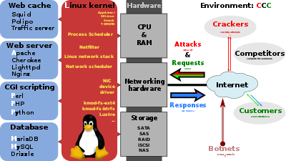](https://en.wikipedia.org/wiki/File:LAMP_software_bundle.svg)

Though MySQL began as a low-end alternative to more powerful proprietary databases, it has gradually evolved to support higher-scale needs as well. It is still most commonly used in small to medium scale single-server deployments, either as a component in a [LAMP](https://en.wikipedia.org/wiki/LAMP_(software_bundle))-based web application or as a standalone database server. Much of MySQL's appeal originates in its relative simplicity and ease of use, which is enabled by an ecosystem of open source tools such as [phpMyAdmin](https://en.wikipedia.org/wiki/PhpMyAdmin). In the medium range, MySQL can be scaled by deploying it on more powerful hardware, such as a multi-processor server with gigabytes of memory.

There are, however, limits to how far performance can scale on a single server ('scaling up'), so on larger scales, multi-server MySQL ('scaling out') deployments are required to provide improved performance and reliability. A typical high-end configuration can include a powerful master database which handles data write operations and is [replicated](https://en.wikipedia.org/wiki/Database_replication) to multiple slaves that handle all read operations. The master server continually pushes binlog events to connected slaves so in the event of failure a slave can be promoted to become the new master, minimizing downtime. Further improvements in performance can be achieved by caching the results from database queries in memory using [Memcached](https://en.wikipedia.org/wiki/Memcached), or breaking down a database into smaller chunks called [shards](https://en.wikipedia.org/wiki/Shard_(database_architecture)) which can be spread across a number of distributed server clusters.

High availability software:

Oracle MySQL offers a high availability solution with a mix of tools including the MySQL router and the MySQL shell. They are based on Group Replication, open source tools. MariaDB offers a similar offer in terms of products.

Cloud deployment:

MySQL can also be run on cloud computing platforms such as Microsoft Azure, Amazon EC2, Oracle Cloud Infrastructure. Some common deployment models for MySQL on the cloud are:

Virtual machine image:

In this implementation, cloud users can upload a machine image of their own with MySQL installed, or use a ready-made machine image with an optimized installation of MySQL on it, such as the one provided by Amazon EC2.

MySQL as a service:

Some cloud platforms offer MySQL "as a service". In this configuration, application owners do not have to install and maintain the MySQL database on their own. Instead, the database service provider takes responsibility for installing and maintaining the database, and application owners pay according to their usage.[100] Notable cloud-based MySQL services are the Amazon Relational Database Service; Oracle MySQL Cloud Service, Azure Database for MySQL, Rackspace; HP Converged Cloud; Heroku and Jelastic. In this model the database service provider takes responsibility for maintaining the host and database.

User interfaces:

Graphical user interfaces:

A graphical user interface (GUI) is a type of interface that allows users to interact with electronic devices or programs through graphical icons and visual indicators such as secondary notation, as opposed to text-based interfaces, typed command labels or text navigation. GUIs are easier to learn than command-line interfaces (CLIs), which require commands to be typed on the keyboard. Third-party proprietary and free graphical administration applications (or "front ends") are available that integrate with MySQL and enable users to work with database structure and data visually. Some well-known front ends are:

MySQL Workbench:

MySQL Workbench is the official integrated environment for MySQL. It was developed by MySQL AB, and enables users to graphically administer MySQL databases and visually design database structures. MySQL Workbench replaces the previous package of software, MySQL GUI Tools. Similar to other third-party packages, but still considered the authoritative MySQL front end, MySQL Workbench lets users manage database design & modeling, SQL development (replacing MySQL Query Browser) and Database administration (replacing MySQL Administrator). MySQL Workbench is available in two editions, the regular free and open source Community Edition which may be downloaded from the MySQL website, and the proprietary Standard Edition which extends and improves the feature set of the Community Edition

Command-line interfaces:

A command-line interface is a means of interacting with a computer program where the user issues commands to the program by typing in successive lines of text (command lines). MySQL ships with many command line tools, from which the main interface is the mysql client. MySQL Utilities is a set of utilities designed to perform common maintenance and administrative tasks. Originally included as part of the MySQL Workbench, the utilities are a stand-alone download available from Oracle. Percona Toolkit is a cross-platform toolkit for MySQL, developed in Perl. Percona Toolkit can be used to prove replication is working correctly, fix corrupted data, automate repetitive tasks, and speed up servers. Percona Toolkit is included with several Linux distributions such as CentOS and Debian, and packages are available for Fedora and Ubuntu as well. Percona Toolkit was originally developed as Maatkit, but as of late 2011, Maatkit is no longer developed. MySQL shell is a tool for interactive use and administration of the MySQL database. It supports JavaScript, Python or SQL modes and it can be used for administration and access purposes.

HTML:

Hypertext Markup Language (HTML) is the standard markup language for documents designed to be displayed in a web browser. It can be assisted by technologies such as Cascading Style Sheets (CSS) and scripting languages such as JavaScript. Web browsers receive HTML documents from a web server or from local storage and render the documents into multimedia web pages. HTML describes the structure of a web page semantically and originally included cues for the appearance of the document. HTML elements are the building blocks of HTML pages. With HTML constructs, images and other objects such as interactive forms may be embedded into the rendered page. HTML provides a means to create structured documents by denoting structural semantics for text such as headings, paragraphs, lists, links, quotes and other items. HTML elements are delineated by tags, written using angle brackets. Tags such as <img /> and <input /> directly introduce content into the page. Other tags such as <p> surround and provide information about document text and may include other tags as sub-elements. Browsers do not display the HTML tags, but use them to interpret the content of the page.

HTML can embed programs written in a scripting language such as JavaScript, which affects the behavior and content of web pages. Inclusion of CSS defines the look and layout of content. The World Wide Web Consortium (W3C), former maintainer of the HTML and current maintainer of the CSS standards, has encouraged the use of CSS over explicit presentational HTML since 1997.

HTML markup consists of several key components, including those called tags (and their attributes), character-based data types, character references and entity references. HTML tags most commonly come in pairs like <h1> and </h1>, although some represent empty elements and so are unpaired, for example <img>. The first tag in such a pair is the start tag, and the second is the end tag (they are also called opening tags and closing tags). Another important component is the HTML document type declaration, which triggers standards mode rendering.

ELEMENTS:

In the simple, general case, the extent of an element is indicated by a pair of tags: a "start tag" <p> and "end tag" </p>. The text content of the element, if any, is placed between these tags. Tags may also enclose further tag markup between the start and end, including a mixture of tags and text. This indicates further (nested) elements, as children of the parent element. The start tag may also include attributes within the tag. These indicate other information, such as identifiers for sections within the document, identifiers used to bind style information to the presentation of the document, and for some tags such as the <img> used to embed images, the reference to the image resource. Some elements, such as the line break <br>, do not permit any embedded content, either text or further tags. These require only a single empty tag (akin to a start tag) and do not use an end tag. Many tags, particularly the closing end tag for the very commonly used paragraph element <p>, are optional. An HTML browser or other agent can infer the closure for the end of an element from the context and the structural rules defined by the HTML standard. These rules are complex and not widely understood by most HTML coders. The general form of an HTML element is therefore: <tag attribute1="value1" attribute2="value2">''content''</tag>. Some HTML elements are defined as empty elements and take the form <tag attribute1="value1" attribute2="value2">. Empty elements may enclose no content, for instance, the <br> tag or the inline <img> tag. The name of an HTML element is the name used in the tags. Note that the end tag's name is preceded by a slash character, /, and that in empty elements the end tag is neither required nor allowed. If attributes are not mentioned, default values are used in each case.

ATTRIBUTES:

Most of the attributes of an element are name-value pairs, separated by = and written within the start tag of an element after the element's name. The value may be enclosed in single or double quotes, although values consisting of certain characters can be left unquoted in HTML (but not XHTML). Leaving attribute values unquoted is considered unsafe. In contrast with name-value pair attributes, there are some attributes that affect the element simply by their presence in the start tag of the element, like the ismap attribute for the img element. There are several common attributes that may appear in many elements :

The id attribute provides a document-wide unique identifier for an element. This is used to identify the element so that stylesheets can alter its presentational properties, and scripts may alter, animate or delete its contents or presentation. Appended to the URL of the page, it provides a globally unique identifier for the element, typically a sub-section of the page.

The class attribute provides a way of classifying similar elements. This can be used for semantic or presentation purposes. For example, an HTML document might semantically use the designation <class="notation"> to indicate that all elements with this class value are subordinate to the main text of the document. In presentation, such elements might be gathered together and presented as footnotes on a page instead of appearing in the place where they occur in the HTML source. Class attributes are used semantically in micro formats. Multiple class values may be specified; for example <class="notation important"> puts the element into both the notation and the important classes.

AWS:

Amazon Relational Database Service (or Amazon RDS) is a distributed relational database service by Amazon Web Services (AWS).It is a web service running "in the cloud" designed to simplify the setup, operation, and scaling of a relational database for use in applications. Administration processes like patching the database software, backing up databases and enabling point-in-time recovery are managed automatically. Scaling storage and compute resources can be performed by a single API call as AWS does not offer an ssh connection to RDS instances.

Features:

New database instances can be launched from the AWS Management Console or using the Amazon RDS APIs. Amazon RDS offers different features to support different use cases. Some of the major features are:

Multi-Availability Zone (AZ) deployment:

In May 2010 Amazon announced Multi-Availability Zone deployment support. Amazon RDS Multi-Availability Zone (AZ) allows users to automatically provision and maintain a synchronous physical or logical "standby" replica, depending on database engine, in a different Availability Zone (independent infrastructure in a physically separate location). Multi-AZ database instance can be developed at creation time or modified to run as a Multi-AZ deployment later. Multi-AZ deployments aim to provide enhanced availability and data durability for MySQL, MariaDB, Oracle, PostgreSQL and SQL Server instances and are targeted for production environments. In the event of planned database maintenance or unplanned service disruption, Amazon RDS automatically fails over to the up-to-date standby, allowing database operations to resume without administrative intervention. Multi-AZ RDS instances are optional and have a cost associated with them. When creating a RDS instance, the user is asked if they would like to use a Multi-AZ RDS instance. In Multi-AZ RDS deployments backups are done in the standby instance so I/O activity is not suspended any time but you may experience elevated latencies for a few minutes during backups.

Read replicas:

Read replicas allow different uses case such as to scale in for read-heavy database workloads. Available are up to five replicas for MySQL, MariaDB, and PostgreSQL instances use the native, asynchronous replication functionality of their respective database engines, have no backups configured by default and are accessible and can be used for read scaling. MySQL and MariaDB read replicas can be made writeable again since October 2012; PostgreSQL read replicas do not support it. Replicas are done at database server level and do not support replication at database instance or table level.

Performance metrics and monitoring:

Performance metrics for Amazon RDS are available from the AWS Management Console or the Amazon CloudWatch API. In December 2015, Amazon announced an optional enhanced monitoring feature that provides an expanded set of metrics for the MySQL, MariaDB, and Aurora database engines.

RDS costs:

Amazon RDS instances are priced very similarly to Amazon Elastic Compute Cloud (EC2). RDS is charged per hour and comes in two packages: On-Demand DB Instances and Reserved DB Instances. On-Demand Instances are at an ongoing hourly usage rate. Reserved DB Instances require an up-front, one-time fee and in turn provide a discount on the hourly usage charge for that instance. Apart from the hourly cost of running the RDS instance, users are charged for the amount of storage provisioned, data transfers and input and output operations performed. AWS have introduced Provisioned Input and Output Operations, in which the user can define how many IO per second are required by their application. IOPS can contribute significantly to the total cost of running the RDS instance. As part of the AWS Free Tier, the Amazon RDS Free Tier helps new AWS customers get started with a managed database service in the cloud for free. You can use the Amazon RDS Free Tier to develop new applications, test existing applications, or simply gain hands-on experience with Amazon RDS.

Automatic backups:

Amazon RDS creates and saves automated backups of RDS DB instances.The first snapshot of a DB instance contains the data for the full DB instance and subsequent snapshots are incremental, maximum retention period is 35 days. In Multi-AZ RDS deployments backups are done in the standby instance so I/O activity is not suspended for any amount of time but you may experience elevated latencies for a few minutes during backups.

Operation:

Database instances can be managed from the AWS Management Console, using the Amazon RDS APIs and using aws cli. Since 1 June 2017, you can stop AWS RDS instances from AWS Management Console or AWS CLI for 7 days at a time. After 7 days, it will be automatically started, and since September 2018 RDS instances can be protected from accidental deletion. Increase DB space is supported, but not decrease allocated space. Additionally there is at least a six-hour period where new allocation cannot be done.

BOOTSTRAP:

Bootstrap is a free and open-source CSS framework directed at responsive, mobile-first front-end web development. It contains CSS- and (optionally) JavaScript-based design templates for typography, forms, buttons, navigation, and other interface components. Bootstrap is the sixth-most-starred project on GitHub, with more than 135,000 stars, behind freeCodeCamp (almost 307,000 stars) and marginally behind Vue.js framework. According to Alexa Rank, Bootstrap is in the top-2000 in the USA while vuejs.org is in the top-7000 in the USA.

Bootstrap, originally named Twitter Blueprint, was developed by Mark Otto and Jacob Thornton at Twitter as a framework to encourage consistency across internal tools. Before Bootstrap, various libraries were used for interface development, which led to inconsistencies and a high maintenance burden. According to Twitter developer Mark Otto:

A super small group of developers and I got together to design and build a new internal tool and saw an opportunity to do something more. Through that process, we saw ourselves build something much more substantial than another internal tool. Months later, we ended up with an early version of Bootstrap as a way to document and share common design patterns and assets within the company. After a few months of development by a small group, many developers at Twitter began to contribute to the project as a part of Hack Week, a hackathon-style week for the Twitter development team. It was renamed from Twitter Blueprint to Bootstrap, and released as an open source project on August 19, 2011. It has continued to be maintained by Mark Otto, Jacob Thornton, and a small group of core developers, as well as a large community of contributors

FEATURES:

Bootstrap is a web framework that focuses on simplifying the development of informative web pages (as opposed to web apps). The primary purpose of adding it to a web project is to apply Bootstrap's choices of color, size, font and layout to that project. As such, the primary factor is whether the developers in charge find those choices to their liking. Once added to a project, Bootstrap provides basic style definitions for all HTML elements. The result is a uniform appearance for prose, tables and form elements across web browsers. In addition, developers can take advantage of CSS classes defined in Bootstrap to further customize the appearance of their contents. Bootstrap also comes with several JavaScript components in the form of jQuery plugins. They provide additional user interface elements such as dialog boxes, tooltips, and carousels. Each Bootstrap component consists of an HTML structure, CSS declarations, and in some cases accompanying JavaScript code. They also extend the functionality of some existing interface elements.

The most prominent components of Bootstrap are its layout components, as they affect an entire web page. The basic layout component is called "Container", as every other element in the page is placed in it. Developers can choose between a fixed-width container and a fluid-width container. While the latter always fills the width of the web page, the former uses one of the four predefined fixed widths, depending on the size of the screen showing the page:

Smaller than 576 pixels

576–768 pixels

768–992 pixels

992–1200 pixels

Larger than 1200 pixels

Once a container is in place, other Bootstrap layout components implement a CSS Flexbox layout through defining rows and columns. A precompiled version of Bootstrap is available in the form of one CSS file and three JavaScript files that can be readily added to any project. The raw form of Bootstrap, however, enables developers to implement further customization and size optimizations. This raw form is modular, meaning that the developer can remove unneeded components, apply a theme and modify the uncompiled Sass files.

SIGNIFICANCE:

Major rewrite of the code

Replacing Less with Sass

Addition of Reboot, a collection of element-specific CSS changes in a single file, based on Normalize

Dropping support for IE8, IE9,[contradictory] and iOS 6

CSS Flexible Box support

Adding navigation customization options

Adding responsive spacing and sizing utilities

Switching from the pixels unit in CSS to root ems

Increasing global font size from 14px to 16px

Dropping the panel, thumbnail, pager, and well component

HEROKU:

Heroku is a cloud platform as a service (PaaS) supporting several programming languages. One of the first cloud platforms, Heroku has been in development since June 2007, when it supported only the Ruby programming language, but now supports Java, Node.js, Scala, Clojure, Python, PHP, and Go. For this reason, Heroku is said to be a polyglot platform as it has features for a developer to build, run and scale applications in a similar manner across most languages. Heroku was acquired by Salesforce.com in 2010 for $212 million.

Heroku was initially developed by James Linden Baum, Adam Wiggins, and Orion Henry for supporting projects that were compatible with the Ruby programming platform known as Rack The prototype development took around six months. Later on, Heroku faced drawbacks because of lack of proper market customers as many app developers used their own tools and environment.[citation needed] In Jan 2009 a new platform was launched which was built almost from scratch after a three-month effort. In October 2009, Byron Sebastian joined Heroku as CEO. On December 8, 2010, Salesforce.com acquired Heroku as a wholly owned subsidiary of Salesforce.com. On July 12, 2011, Yukihiro "Matz" Matsumoto, the chief designer of the Ruby programming language, joined the company as Chief Architect, Ruby. That same month, Heroku added support for Node.js and Clojure. On September 15, 2011, Heroku and Facebook introduced Heroku for Facebook.[10] At present Heroku supports Redis databases in addition to its standard PostgreSQL.

Architecture:

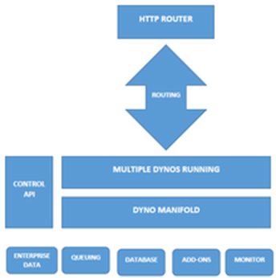

Applications that are run on Heroku typically have a unique domain (typically "applicationname.herokuapp.com") used to route HTTP requests to the correct application container, or dyno. Each of the dynos are spread across a "dyno grid" which consists of several servers. Heroku's Git server handles application repository pushes from permitted users. All Heroku services are hosted on Amazon's EC2 cloud-computing platform.

The Heroku Platform:

The Heroku network runs the customer's apps in virtual containers which execute on a reliable runtime environment. Heroku calls these containers "Dynos." These Dynos can run code written in Node, Ruby, PHP, Go, Scala, Python, Java, or Clojure. Heroku also provides custom buildpacks with which the developer can deploy apps in any other language. Heroku lets the developer scale the app instantly just by either increasing the number of dynos or by changing the type of dyno the app runs in.

Heroku Postgres:

Heroku Postgres is the Cloud database (DBaaS) service for Heroku based on PostgreSQL. Heroku Postgres provides features like continuous protection, rollback, and high availability; also forks, followers, and dataclips.

Heroku Redis:

Heroku Redis is the customized Redis from Heroku to provide a better developer experience. It is fully managed and is provided as a service by Heroku. It helps in managing instances with a CLI, associate data with Postgres to gain business insights using SQL tools, and lets customer gain performance visibility.

Heroku Teams:

Heroku Teams is a team management tool which provides collaboration and controls to bring a customer's developers, processes, and tools together in order to build better software. With Heroku Teams, teams can self-organize, add, and manage members, get fine-grained control with app-level permissions and also use collaboration tools like Heroku Pipelines. It also provides delegated administration and centralized billing.

Heroku Enterprise:

Heroku Enterprise provides services to large companies which help them to improve collaboration among different teams. It provides a set of features like fine-grained access controls, identity federation, and private spaces to manage their enterprise application development process, resources, and users.

Heroku Connect:

Heroku Connect lets users create Heroku apps that can easily integrate with Salesforce deployments at scale. This is done by having a seamless data synchronization between Heroku Postgres databases and Salesforce organizations.

Heroku Elements:

Heroku Elements provides users with Add-ons -Tools and services for developing, extending, and operating the app, buildpacks automate the build processes for the preferred languages and frameworks and Buttons -one-click provision, configure, and deploy third party components, libraries and pattern app.

1. APPENDIX

SOURCE CODE FOR WEB APPLICATION:

PYTHON:

Model.py:

from django.db import models

from django.contrib.auth.models import User

class Customer(models.Model):

user = models.OneToOneField(User, null=True, blank=True, on_delete=models.CASCADE)

name = models.CharField(max_length=200, null=True)

email = models.CharField(max_length=200)

def __str__(self):

return self.name

class Product(models.Model):

name = models.CharField(max_length=200)

price = models.FloatField()

digital = models.BooleanField(default=False,null=True, blank=True)

image = models.CharField(max_length=2080,null=True)

class meta:

abstract=True

def __str__(self):

return self.name

@property

def imageURL(self):

try:

url = self.image.url

except:

url = ''

return url

class Book(Product):

pass

class Store(Product):

pass

class Electronic(Product):

pass

class Fashion(Product):

pass

class Fruit(Product):

pass

class Vegetable(Product):

pass

class Order(models.Model):

customer = models.ForeignKey(Customer, on_delete=models.SET_NULL, null=True, blank=True)

date_ordered = models.DateTimeField(auto_now_add=True)

complete = models.BooleanField(default=False)

transaction_id = models.CharField(max_length=100, null=True)

def __str__(self):

return str(self.id)

@property

def shipping(self):

shipping = False

orderitems = self.orderitem_set.all()

for i in orderitems:

if i.product.digital == False:

shipping = True

return shipping

@property

def get_cart_total(self):

orderitems = self.orderitem_set.all()

total = sum([item.get_total for item in orderitems])

return total

@property

def get_cart_items(self):

orderitems = self.orderitem_set.all()

total = sum([item.quantity for item in orderitems])

return total

class OrderItem(models.Model):

product = models.ForeignKey(Product, on_delete=models.SET_NULL, null=True)

order = models.ForeignKey(Order, on_delete=models.SET_NULL, null=True)

quantity = models.IntegerField(default=0, null=True, blank=True)

date_added = models.DateTimeField(auto_now_add=True)

@property

def get_total(self):

total = self.product.price * self.quantity

return total

class ShippingAddress(models.Model):

customer = models.ForeignKey(Customer, on_delete=models.SET_NULL, null=True)

order = models.ForeignKey(Order, on_delete=models.SET_NULL, null=True)

address = models.CharField(max_length=200, null=False)

city = models.CharField(max_length=200, null=False)

state = models.CharField(max_length=200, null=False)

zipcode = models.CharField(max_length=200, null=False)

date_added = models.DateTimeField(auto_now_add=True)

def __str__(self):

return self.address

class details(models.Model):

user = models.OneToOneField(User, null=True, blank=True, on_delete=models.CASCADE)

name = models.CharField(max_length=200, null=True)

email = models.CharField(max_length=200)

address = models.CharField(max_length=200, null=False)

city = models.CharField(max_length=200, null=False)

state = models.CharField(max_length=200, null=False)

zipcode = models.CharField(max_length=200, null=False)

date_added = models.DateTimeField(auto_now_add=True)

order = models.ForeignKey(Order, on_delete=models.SET_NULL, null=True)

total=models.IntegerField()

modeofpay = models.CharField(max_length=200, null=True)

url.py:

from django.urls import path

from . import views

urlpatterns = [

#Leave as empty string for base url

path('', views.home, name="home"),

path('cart/', views.cart, name="cart"),

path('checkout/', views.checkout, name="checkout"),

path('books/',views.books, name="books"),

path('stores/',views.stores, name="stores"),

path('vegetables/',views.vegetables, name="vegetables"),

path('fruits/',views.fruits, name="fruits"),

path('electronics/',views.electronics, name="electronics"),

path('fashions/',views.fashions, name="fashions"),

path('update_item/', views.updateItem, name="update_item"),

path('process_order/', views.processOrder, name="process_order"),]

Util.py:

import json

from .models import *

def cookieCart(request):

#Create empty cart for now for non-logged in user

try:

cart = json.loads(request.COOKIES['cart'])

except:

cart = {}

print('CART:', cart)

items = []

order = {'get_cart_total':0, 'get_cart_items':0, 'shipping':False}

cartItems = order['get_cart_items']

for i in cart:

#We use try block to prevent items in cart that may have been removed from causing error

try:

cartItems += cart[i]['quantity']

product = Product.objects.get(id=i)

total = (product.price * cart[i]['quantity'])

order['get_cart_total'] += total

order['get_cart_items'] += cart[i]['quantity']

item = {

'id':product.id,

'product':{

'id':product.id,

'name':product.name,

'price':product.price,

'imageURL':product.imageURL

},

'quantity':cart[i]['quantity'],

'digital':product.digital,

'get_total':total,

}

items.append(item)

if product.digital == False:

order['shipping'] = True

except:

pass

return {'cartItems':cartItems ,'order':order, 'items':items}

def cartData(request):

if request.user.is_authenticated:

customer = request.user.customer

order, created = Order.objects.get_or_create(customer=customer, complete=False)

items = order.orderitem_set.all()

cartItems = order.get_cart_items

else:

cookieData = cookieCart(request)

cartItems = cookieData['cartItems']

order = cookieData['order']

items = cookieData['items']

return {'cartItems':cartItems ,'order':order, 'items':items}

def guestOrder(request, data):

name = data['form']['name']

email = data['form']['email']

cookieData = cookieCart(request)

items = cookieData['items']

customer, created = Customer.objects.get_or_create(

email=email,

)

customer.name = name

customer.save()

order = Order.objects.create(

customer=customer,

complete=False,

)

for item in items:

product = Product.objects.get(id=item['id'])

orderItem = OrderItem.objects.create(

product=product,

order=order,

quantity=item['quantity'],

)

return customer, order

view.py:

import json

from .models import *

def cookieCart(request):

#Create empty cart for now for non-logged in user

try:

cart = json.loads(request.COOKIES['cart'])

except:

cart = {}

print('CART:', cart)

items = []

order = {'get_cart_total':0, 'get_cart_items':0, 'shipping':False}

cartItems = order['get_cart_items']

for i in cart:

#We use try block to prevent items in cart that may have been removed from causing error

try:

cartItems += cart[i]['quantity']

product = Product.objects.get(id=i)

total = (product.price * cart[i]['quantity'])

order['get_cart_total'] += total

order['get_cart_items'] += cart[i]['quantity']

item = {

'id':product.id,

'product':{

'id':product.id,

'name':product.name,

'price':product.price,

'imageURL':product.imageURL

},

'quantity':cart[i]['quantity'],

'digital':product.digital,

'get_total':total,

}

items.append(item)

if product.digital == False:

order['shipping'] = True

except:

pass

return {'cartItems':cartItems ,'order':order, 'items':items}

def cartData(request):

if request.user.is_authenticated:

customer = request.user.customer

order, created = Order.objects.get_or_create(customer=customer, complete=False)

items = order.orderitem_set.all()

cartItems = order.get_cart_items

else:

cookieData = cookieCart(request)

cartItems = cookieData['cartItems']

order = cookieData['order']

items = cookieData['items']

return {'cartItems':cartItems ,'order':order, 'items':items}

def guestOrder(request, data):

name = data['form']['name']

email = data['form']['email']

cookieData = cookieCart(request)

items = cookieData['items']

customer, created = Customer.objects.get_or_create(

email=email,

)

customer.name = name

customer.save()

order = Order.objects.create(

customer=customer,

complete=False,

)

for item in items:

product = Product.objects.get(id=item['id'])

orderItem = OrderItem.objects.create(

product=product,

order=order,

quantity=item['quantity'],

)

return customer, order

Settings.py:

import os

# Build paths inside the project like this: os.path.join(BASE_DIR, ...)

BASE_DIR = os.path.dirname(os.path.dirname(os.path.abspath(__file__)))

# Quick-start development settings - unsuitable for production

# See https://docs.djangoproject.com/en/3.0/howto/deployment/checklist/

# SECURITY WARNING: keep the secret key used in production secret!

SECRET_KEY = '****************’

# SECURITY WARNING: don't run with debug turned on in production!

DEBUG = False

ALLOWED_HOSTS = ['nashkart.herokuapp.com','127.0.0.1']

# Application definition

INSTALLED_APPS = [

'django.contrib.admin',

'django.contrib.auth',

'django.contrib.contenttypes',

'django.contrib.sessions',

'django.contrib.messages',

'django.contrib.staticfiles',

'Nashkart',

]

MIDDLEWARE = [

'django.middleware.security.SecurityMiddleware',

'whitenoise.middleware.WhiteNoiseMiddleware',

'django.contrib.sessions.middleware.SessionMiddleware',

'django.middleware.common.CommonMiddleware',

'django.middleware.csrf.CsrfViewMiddleware',

'django.contrib.auth.middleware.AuthenticationMiddleware',

'django.contrib.messages.middleware.MessageMiddleware',

'django.middleware.clickjacking.XFrameOptionsMiddleware',

]

ROOT_URLCONF = 'Nashcommerce.urls'

TEMPLATES = [

{

'BACKEND': 'django.template.backends.django.DjangoTemplates',

'DIRS': [],

'APP_DIRS': True,

'OPTIONS': {

'context_processors': [

'django.template.context_processors.debug',

'django.template.context_processors.request',

'django.contrib.auth.context_processors.auth',

'django.contrib.messages.context_processors.messages',

],

},

},

]

WSGI_APPLICATION = 'Nashcommerce.wsgi.application'

# Database

# https://docs.djangoproject.com/en/3.0/ref/settings/#databases

'''

DATABASES = {

'default': {

'ENGINE': 'django.db.backends.mysql',

'NAME': 'nashkartdb',

'HOST': 'database-1.ckwctrdkgjxd.ap-south-1.rds.amazonaws.com',

'PORT': '3306',

'USER': 'Nash',

'PASSWORD': '*****’.

}

}

'''

DATABASES = {

'default': {

'ENGINE': 'django.db.backends.sqlite3',

'NAME': os.path.join(BASE_DIR, 'db.sqlite3'),

}

}

# Password validation

# https://docs.djangoproject.com/en/3.0/ref/settings/#auth-password-validators

AUTH_PASSWORD_VALIDATORS = [

{

'NAME': 'django.contrib.auth.password_validation.UserAttributeSimilarityValidator',

},

{

'NAME': 'django.contrib.auth.password_validation.MinimumLengthValidator',

},

{

'NAME': 'django.contrib.auth.password_validation.CommonPasswordValidator',

},

{

'NAME': 'django.contrib.auth.password_validation.NumericPasswordValidator',

},

]

# Internationalization

# https://docs.djangoproject.com/en/3.0/topics/i18n/

LANGUAGE_CODE = 'en-us'

TIME_ZONE = 'UTC'

USE_I18N = True

USE_L10N = True

USE_TZ = True

# Static files (CSS, JavaScript, Images)

# https://docs.djangoproject.com/en/3.0/howto/static-files/

STATIC_ROOT = os.path.join(BASE_DIR, 'staticfiles')

STATIC_URL = '/static/'

STATICFILES_DIRS = [

os.path.join(BASE_DIR, 'static')

]

MEDIA_URL = '/images/

'MEDIA_ROOT = os.path.join(BASE_DIR, 'static/images')

JAVASCRIPT:

var updateBtns = document.getElementsByClassName('update-cart')

for (i = 0; i < updateBtns.length; i++) {

updateBtns[i].addEventListener('click', function(){

var productId = this.dataset.product

var action = this.dataset.action

console.log('productId:', productId, 'Action:', action)

console.log('USER:', user)

if (user == 'AnonymousUser'){

addCookieItem(productId, action)

}else{

updateUserOrder(productId, action)

}

})

}

function updateUserOrder(productId, action){

console.log('User is authenticated, sending data...')

var url = '/update_item/'

fetch(url, {

method:'POST',

headers:{

'Content-Type':'application/json',

'X-CSRFToken':csrftoken,

},

body:JSON.stringify({'productId':productId, 'action':action})

})

.then((response) => {

return response.json();

})

.then((data) => {

location.reload()

});

}

function addCookieItem(productId, action){

console.log('User is not authenticated')

if (action == 'add'){

if (cart[productId] == undefined){

cart[productId] = {'quantity':1}

}else{

cart[productId]['quantity'] += 1

}

}

if (action == 'remove'){

cart[productId]['quantity'] -= 1

if (cart[productId]['quantity'] <= 0){

console.log('Item should be deleted')

delete cart[productId];

}

}

console.log('CART:', cart)

document.cookie ='cart=' + JSON.stringify(cart) + ";domain=;path=/"

location.reload()

}

CSS:

body{

background-color: hsl(0, 0%, 98%);

}

h1,h2,h3,h4,h5,h6{

color:hsl(0, 0%, 30%);

}

.box-element{

box-shadow:hsl(0, 0%, 80%) 0 0 16px;

background-color: #fff;

border-radius: 4px;

padding: 10px;

}

.thumbnail{

width: 100%;

height: 200px;

-webkit-box-shadow: -1px -3px 5px -2px rgba(214,214,214,1);

-moz-box-shadow: -1px -3px 5px -2px rgba(214,214,214,1);

box-shadow: -1px -3px 5px -2px rgba(214,214,214,1);

}

.product{

border-radius: 0 0 4px 4px;

}

.bg-dark{

background-color: #770c77!important;

}

#cart-icon{

width:25px;

display: inline-block;

margin-left: 15px;

}

#cart-total{

display: block;

text-align: center;

color:#fff;

background-color: red;

width: 20px;

height: 25px;

border-radius: 50%;

font-size: 14px;

}

.col-lg-4, .col-lg-6, .col-lg-8, .col-lg-12{

margin-top: 10px;

}

.btn{

border-radius: 0;

}

.row-image{

width: 100px;

}

.form-field{

width:250px;

display: inline-block;

padding: 5px;

}

.cart-row{

display: flex;

align-items: flex-stretch;

padding-bottom: 10px;

margin-bottom: 10px;

border-bottom: 1px solid #ececec;

}

.quantity{

display: inline-block;

font-weight: 700;

padding-right:10px;

}

.chg-quantity{

width: 12px;

cursor: pointer;

display: block;

margin-top: 5px;

transition:.1s;

}

.chg-quantity:hover{

opacity: .6;

}

.hidden{

display: none!important;

}

HTML:

Main.html:

<html>

<head>

<title>Ecom</title>

<meta name="viewport" content="width=device-width, initial-scale=1, maximum-scale=1, minimum-scale=1" />

<link rel="stylesheet" href="https://stackpath.bootstrapcdn.com/bootstrap/4.4.1/css/bootstrap.min.css" integrity="sha384-Vkoo8x4CGsO3+Hhxv8T/Q5PaXtkKtu6ug5TOeNV6gBiFeWPGFN9MuhOf23Q9Ifjh" crossorigin="anonymous">

<link rel="stylesheet" type="text/css" href="{% static 'css/main.css' %}">

<script type="text/javascript">

var user = '{{request.user}}'

function getToken(name) {

var cookieValue = null;

if (document.cookie && document.cookie !== '') {

var cookies = document.cookie.split(';');

for (var i = 0; i < cookies.length; i++) {

var cookie = cookies[i].trim();

// Does this cookie string begin with the name we want?

if (cookie.substring(0, name.length + 1) === (name + '=')) {

cookieValue = decodeURIComponent(cookie.substring(name.length + 1));

break;

}

}

}

return cookieValue;

}

var csrftoken = getToken('csrftoken')

function getCookie(name) {

// Split cookie string and get all individual name=value pairs in an array

var cookieArr = document.cookie.split(";");

// Loop through the array elements

for(var i = 0; i < cookieArr.length; i++) {

var cookiePair = cookieArr[i].split("=");

/* Removing whitespace at the beginning of the cookie name

and compare it with the given string */

if(name == cookiePair[0].trim()) {

// Decode the cookie value and return

return decodeURIComponent(cookiePair[1]);

}

}

// Return null if not found

return null;

}

var cart = JSON.parse(getCookie('cart'))

if (cart == undefined){

cart = {}

console.log('Cart Created!', cart)

document.cookie ='cart=' + JSON.stringify(cart) + ";domain=;path=/"

}

console.log('Cart:', cart)

</script>

</head>

<body>

<nav class="navbar navbar-expand-lg navbar-dark bg-dark">

<a class="navbar-brand" href="{% url 'home' %}">NASHKART</a>

<button class="navbar-toggler" type="button" data-toggle="collapse" data-target="#navbarSupportedContent" aria-controls="navbarSupportedContent" aria-expanded="false" aria-label="Toggle navigation">

<span class="navbar-toggler-icon"></span>

</button>

<div class="collapse navbar-collapse" id="navbarSupportedContent">

<ul class="navbar-nav mr-auto">

<li class="nav-item active">

<a class="nav-link" href="{% url 'home' %}">Home <span class="sr-only">(current)</span></a>

</li>

<li class="nav-item active">

<a class="nav-link" href="{% url 'stores' %}">Store <span class="sr-only">(current)</span></a>

</li>

<li class="nav-item active">

<a class="nav-link" href="{% url 'books' %}">Books <span class="sr-only">(current)</span></a>

</li>

<li class="nav-item active">

<a class="nav-link" href="{% url 'electronics' %}">Electronics <span class="sr-only">(current)</span></a>

</li>

<li class="nav-item active">

<a class="nav-link" href="{% url 'vegetables' %}">Vegetables <span class="sr-only">(current)</span></a>

</li>

<li class="nav-item active">

<a class="nav-link" href="{% url 'fruits' %}">Fruits <span class="sr-only">(current)</span></a>

</li>

<li class="nav-item active">

<a class="nav-link" href="{% url 'fashions' %}">Fashion <span class="sr-only">(current)</span></a>

</li>

</ul>

<a href="{% url 'cart' %}">

<img id="cart-icon" src="{% static 'images/cart.png' %}">

</a>

<p id="cart-total">{{cartItems}}</p>

</div>

</div>

</nav>

<div class="container">

<br>

{% block content %}

{% endblock content %}

</div>

<script src="https://code.jquery.com/jquery-3.4.1.slim.min.js" integrity="sha384-J6qa4849blE2+poT4WnyKhv5vZF5SrPo0iEjwBvKU7imGFAV0wwj1yYfoRSJoZ+n" crossorigin="anonymous"></script>

<script src="https://cdn.jsdelivr.net/npm/popper.js@1.16.0/dist/umd/popper.min.js" integrity="sha384-Q6E9RHvbIyZFJoft+2mJbHaEWldlvI9IOYy5n3zV9zzTtmI3UksdQRVvoxMfooAo" crossorigin="anonymous"></script>

<script src="https://stackpath.bootstrapcdn.com/bootstrap/4.4.1/js/bootstrap.min.js" integrity="sha384-wfSDF2E50Y2D1uUdj0O3uMBJnjuUD4Ih7YwaYd1iqfktj0Uod8GCExl3Og8ifwB6" crossorigin="anonymous"></script>

<script type="text/javascript" src="{% static 'js/cart.js' %}"></script>

&copy;A Project by Nash

</body>

</html>

books.html:

{% extends 'store/main.html' %}

{% load static %}

{% block content %}

<div class="row">

{% for bp in books %}

<div class="col-lg-4">

<img class="thumbnail" src="{{bp.image}}">

<div class="box-element product">

<h6><strong>{{bp.name}}</strong></h6>

<hr> <button data-product="{{bp.id}}" data-action="add" class="btn btn-outline-secondary add-btn update-cart">Add to Cart</button>

<h4 style="display: inline-block; float: right"><strong>Rs.{{bp.price}}</strong></h4>

</div>

</div>

{% endfor %}

</div>

{% endblock content %}

cart.html:

<br><div class="row">

<div class="col-lg-12">

<div class="box-element">

<a class="btn btn-outline-dark" href="{% url 'home' %}">&#x2190; Continue Shopping</a>

<br>

<br>

<table class="table">

<tr>

<th><h5>Items: <strong>{{order.get_cart_items}}</strong></h5></th>

<th><h5>Total:<strong> Rs.{{order.get_cart_total|floatformat:2}}</strong></h5></th>

<th>

<a style="float:right; margin:5px;" class="btn btn-success" href="{% url 'checkout' %}">Checkout</a>

</th>

</tr>

<div class="box-element">

<div class="cart-row">

<div style="flex:2"></div>

<div style="flex:2"><strong>Item</strong></div>

<div style="flex:1"><strong>Price</strong></div>

<div style="flex:1"><strong>Quantity</strong></div>

<div style="flex:1"><strong>Total</strong></div>

</div>

{% for item in items %}

<div class="cart-row">

<div style="flex:2"><img class="row-image" src="{{item.product.image}}"></div>

<div style="flex:2"><p>{{item.product.name}}</p></div>

<div style="flex:1"><p>Rs.{{item.product.price|floatformat:2}}</p></div>

<div style="flex:1">

<p class="quantity">{{item.quantity}}</p>

<div class="quantity">

<img data-product="{{item.product.id}}" data-action="add" class="chg-quantity update-cart" src="{% static 'images/arrow-up.png' %}">

<img data-product="{{item.product.id}}" data-action="remove" class="chg-quantity update-cart" src="{% static 'images/arrow-down.png' %}">

</div>

</div>

<div style="flex:1"><p>Rs.{{item.get_total|floatformat:2}}</p></div>

</div>

{% endfor %}

</div>

</div>

</div>

Checkout.html:

<div class="row">

<div class="col-lg-6">

<div class="box-element" id="form-wrapper">

<form id="form">

<div id="user-info">

<div class="form-field">

<input required class="form-control" type="text" name="name" placeholder="Name..">

</div>

<div class="form-field">

<input required class="form-control" type="email" name="email" placeholder="Email..">

</div>

</div>

<div id="shipping-info">

<hr>

<p>Shipping Information:</p>

<hr>

<div class="form-field">

<input class="form-control" type="text" name="address" placeholder="Address..">

</div>

<div class="form-field">

<input class="form-control" type="text" name="city" placeholder="City..">

</div>

<div class="form-field">

<input class="form-control" type="text" name="state" placeholder="State..">

</div>

<div class="form-field">

<input class="form-control" type="text" name="country" placeholder="country..">

</div>

<!--

<div class="form-check">

<label class="form-check-label" for="radio1">

<input type="radio" class="form-check-input" id="radio1" name="mode" value="credit" checked>Credit Card

</label>

</div>

<div class="form-check">

<label class="form-check-label" for="radio2">

<input type="radio" class="form-check-input" id="radio2" name="mode" value="Debit">Option 2

</label>

</div>

<div class="form-check">

<label class="form-check-label">

<input type="radio" class="form-check-input" disabled>Option 3

</label>

</div>-->

<label>Mode of pay</label>

<select class="form-control" name="mode">

<option>credit</option>

<option>debit</option>

<option>cash</option>

<option>net banking</option>

</select>

</div>

<hr>

<input id="form-button" class="btn btn-success btn-block" type="submit" value="Continue">

</form>

</div>

<br>

<div class="box-element hidden" id="payment-info">

<button id="make-payment">Make payment</button>

</div>

</div>

<div class="col-lg-6">

<div class="box-element">

<a class="btn btn-outline-dark" href="{% url 'cart' %}">&#x2190; Back to Cart</a>

<hr>

<h3>Order Summary</h3>

<hr>

{% for item in items %}

<div class="cart-row">

<div style="flex:2"><img class="row-image" src="{{item.product.image}}"></div>

<div style="flex:2"><p>{{item.product.name}}</p></div>

<div style="flex:1"><p>${{item.product.price|floatformat:2}}</p></div>

<div style="flex:1"><p>x{{item.quantity}}</p></div>

</div>

{% endfor %}

<h5>Items: {{order.get_cart_items}}</h5>

<h5>Total: Rs.{{order.get_cart_total|floatformat:2}}</h5>

</div>

</div>

</div>

<script type="text/javascript">

var shipping = '{{order.shipping}}'

var total = '{{order.get_cart_total|floatformat:2}}'

if (shipping == 'False'){

document.getElementById('shipping-info').innerHTML = ''

}

/*

if (user != 'AnonymousUser'){

document.getElementById('user-info').innerHTML = ''

}

if (shipping == 'False' && user != 'AnonymousUser'){

//Hide entire form if user is logged in and shipping is false

document.getElementById('form-wrapper').classList.add("hidden");

//Show payment if logged in user wants to buy an item that does not require shipping

document.getElementById('payment-info').classList.remove("hidden");

}

*/

var form = document.getElementById('form')

form.addEventListener('submit', function(e){

e.preventDefault()

console.log('Form Submitted...')

document.getElementById('form-button').classList.add("hidden");

document.getElementById('payment-info').classList.remove("hidden");

})

document.getElementById('make-payment').addEventListener('click', function(e){

submitFormData()

})

function submitFormData(){

console.log('Payment button clicked')

var userFormData = {

'name':null,

'email':null,

'total':total,

}

var shippingInfo = {

'address':null,

'city':null,

'state':null,

'country':null,

'mode':null,

}

/* <div id="mop">

<label>Mode of pay</label>

<select class="form-control" name="mode">

<option>credit</option>

<option>debit</option>

<option>cash</option>

<option>net banking</option>

</select>

</div>

var payinfo={

'mode':null,

}

payinfo.mode=mop.mode.value

*/

if (shipping != 'False'){

shippingInfo.address = form.address.value

shippingInfo.city = form.city.value

shippingInfo.state = form.state.value

shippingInfo.country = form.country.value

shippingInfo.mode = form.mode.value

}

if (user == 'AnonymousUser' || user != 'AnonymousUser'){

userFormData.name = form.name.value

userFormData.email = form.email.value

}

console.log('Shipping Info:', shippingInfo)

console.log('User Info:', userFormData)

var url = "/process_order/"

fetch(url, {

method:'POST',

headers:{

'Content-Type':'applicaiton/json',

'X-CSRFToken':csrftoken,

},

body:JSON.stringify({'form':userFormData, 'shipping':shippingInfo}),

})

.then((response) => response.json())

.then((data) => {

console.log('Success:', data);

alert('Transaction completed');

cart = {}

document.cookie ='cart=' + JSON.stringify(cart) + ";domain=;path=/"

window.location.href = "{% url 'home' %}"

})

}

</script>

Electronics.html:

<div class="row">

{% for elec in elect %}

<div class="col-lg-4">

<img class="thumbnail" src="{{elec.image}}">

<div class="box-element product">

<h6><strong>{{elec.name}}</strong></h6>

<hr>

<button data-product="{{elec.id}}" data-action="add" class="btn btn-outline-secondary add-btn update-cart">Add to Cart</button>

<h4 style="display: inline-block; float: right"><strong>Rs.{{elec.price}}</strong></h4>

</div>

</div>

{% endfor %}

</div>

Fashion.html:

<div class="row">

{% for fas in fash %}

<div class="col-lg-4">

<img class="thumbnail" src="{{fas.image}}">

<div class="box-element product">

<h6><strong>{{fas.name}}</strong></h6>

<hr>

<button data-product="{{fas.id}}" data-action="add" class="btn btn-outline-secondary add-btn update-cart">Add to Cart</button>

<h4 style="display: inline-block; float: right"><strong>Rs.{{fas.price}}</strong></h4>

</div>

</div>

{% endfor %}

</div>

Fruits.hml:

<div class="row">

{% for fruit in frui %}

<div class="col-lg-4">

<img class="thumbnail" src="{{fruit.image}}">

<div class="box-element product">

<h6><strong>{{fruit.name}}</strong></h6>

<hr>

<button data-product="{{fruit.id}}" data-action="add" class="btn btn-outline-secondary add-btn update-cart">Add to Cart</button>

<h4 style="display: inline-block; float: right"><strong>Rs.{{fruit.price}}</strong></h4>

</div>

</div>

{% endfor %}

</div>

Home.html:

<div id="carouselExampleIndicators" class="carousel slide" data-ride="carousel">

<ol class="carousel-indicators">

<li data-target="#carouselExampleIndicators" data-slide-to="0" class="active"></li>

<li data-target="#carouselExampleIndicators" data-slide-to="1"></li>

<li data-target="#carouselExampleIndicators" data-slide-to="2"></li>

</ol>

<div class="carousel-inner">

<div class="carousel-item active">

<img src="{% static 'images/shopping-cart-grocery.jpg' %}" class="d-block w-100" alt="...">

</div>

<div class="carousel-item">

<img src="{% static 'images/veges.jpg' %}" class="d-block w-100" alt="...">

</div>

<div class="carousel-item">

<img src="{% static 'images/electronic.jpeg' %}" class="d-block w-100" alt="...">

</div>

</div>

<a class="carousel-control-prev" href="#carouselExampleIndicators" role="button" data-slide="prev">

<span class="carousel-control-prev-icon" aria-hidden="true"></span>

<span class="sr-only">Previous</span>

</a>

<a class="carousel-control-next" href="#carouselExampleIndicators" role="button" data-slide="next">

<span class="carousel-control-next-icon" aria-hidden="true"></span>

<span class="sr-only">Next</span>

</a>

</div>

<div>

<div class="alert alert-success" role="alert">

This web Application is developed for the educational purpose.

</div>

</div>

Stores.html:

<div class="row">

{% for st in stor %}

<div class="col-lg-4">

<img class="thumbnail" src="{{st.image}}">

<div class="box-element product">

<h6><strong>{{st.name}}</strong></h6>

<hr>

<button data-product="{{st.id}}" data-action="add" class="btn btn-outline-secondary add-btn update-cart">Add to Cart</button>

<h4 style="display: inline-block; float: right"><strong>Rs.{{st.price}}</strong></h4>

</div>

</div>

{% endfor %}

</div>

Vegetables.html:

<div class="row">

{% for vegetab in veg %}

<div class="col-lg-4">

<img class="thumbnail" src="{{vegetab.image}}">

<div class="box-element product">

<h6><strong>{{vegetab.name}}</strong></h6>

<hr>

<button data-product="{{vegetab.id}}" data-action="add" class="btn btn-outline-secondary add-btn update-cart">Add to Cart</button>

<h4 style="display: inline-block; float: right"><strong>Rs.{{vegetab.price}}</strong></h4>

</div>

</div>

{% endfor %}

</div>

SOURCE CODE FOR PREPROCESSING :

PYTHON :

# IMPORTING PACKAGES

import pymysql

import pandas as pd

#import numpy as np

# CONNECTING TO THE DATABASE

host="*******"

port=****

dbname="****"

user="****"

password="******"

conn = pymysql.connect(host, user=user,port=port,

passwd=password, db=dbname)

# WORKING WITH THE TABLES

details_df=pd.read_sql('select * from Nashkart_details;', con=conn)

items_df=pd.read_sql('select * from Nashkart_orderitem;', con=conn)

product_df=pd.read_sql('select * from Nashkart_product;', con=conn)

# 1. WORKING WITH USER DETAILS

# KNOWING ABOUT DATA

print(details_df)

print(details_df.columns)

print(details_df.info)

print(details_df.describe())

print(details_df.dtypes)

print(details_df)

# CLEANING THE DATA

print(details_df.isnull().sum())

print(pd.isnull(details_df))

print(details_df.isnull().sum())

details_df= details_df.drop('user_id', axis=1)

'''

print(items_df.isnull().sum())

print(items_df[items_df['product_id'].isnull()])

items_df=items_df.dropna()

print(items_df.isnull().sum())

items_df= items_df.drop(['id','date_added'], axis=1)

print(items_df.head())

'''

# INSIGHT OF DETAILS DATA

details_df['sale hour'] = details_df['date_added'].dt.hour

details_df['sale year'] = details_df['date_added'].dt.year

details_df['sale month'] = details_df['date_added'].dt.month

details_df['sale day'] = details_df['date_added'].dt.day

print(details_df.head())

# CLEANING THE COUNTRY

details_df.rename(columns={'zipcode':'country'},inplace=True)

print(details_df.head())

print(details_df['country'].unique())

print(details_df.loc[details_df['country']=="Heaven"])

details_df.drop([107,108,112],inplace=True)

print(details_df['country'].unique())

for i in details_df['country'].unique():

if i == 'USA':

details_df['country'].mask(details_df['country']== i , "United States of America" , inplace = True)

else:

details_df['country'].mask(details_df['country']== i , "India" , inplace = True)

print(details_df['country'].unique())

# CLEANING THE STATE

print(details_df['state'].unique())

details_df.loc[(details_df.state == 'tamil nadu'),'state']='Tamil Nadu'

details_df.loc[(details_df.state == 'Tamil nadu'),'state']='Tamil Nadu'

details_df.loc[(details_df.state == 'tn'),'state']='Tamil Nadu'

details_df.loc[(details_df.state == 'TAMIL NADU'),'state']='Tamil Nadu'

details_df.loc[(details_df.state == 'Tamilnadu '),'state']='Tamil Nadu'

details_df.loc[(details_df.state == 'Tamilnadu'),'state']='Tamil Nadu'

details_df.loc[(details_df.state == 'Tamil Nadu'),'state']='Tamil Nadu'

details_df.loc[(details_df.state == 'Tamil Nadu'),'state']='Tamil Nadu'

details_df.loc[(details_df.state == ''),'state']='Tamil Nadu'

details_df.loc[(details_df.state == 'Delhi'),'state']='New Delhi'

details_df.loc[(details_df.state == 'new delhi'),'state']='New Delhi'

details_df.loc[(details_df.state == 'Madhya Pradesh '),'state']='Madhya Pradesh'

details_df.loc[(details_df.state == 'madhya pradesh'),'state']='Madhya Pradesh'

details_df.loc[(details_df.state == 'maharastra'),'state']='Maharastra'

details_df.loc[(details_df.state == 'Maharashtra'),'state']='Maharastra'

details_df.loc[(details_df.state == 'west bengal'),'state']='West Bengal'

print(details_df['state'].unique())

# CLEANING THE CITY

print(details_df['city'].nunique())

print(details_df['city'].unique())

details_df.loc[(details_df.city == 'chennai'),'city']='Chennai'

details_df.loc[(details_df.city == 'Chennai'),'city']='Chennai'

details_df.loc[(details_df.city == 'CHENNAI'),'city']='Chennai'

details_df.loc[(details_df.city == 'Chennai '),'city']='Chennai'

details_df.loc[(details_df.city == 'kilpauk'),'city']='Chennai'

details_df.loc[(details_df.city == 'madurai'),'city']='Madurai'

details_df.loc[(details_df.city == 'salem'),'city']='Salem'

details_df.loc[(details_df.city == 'bangalore'),'city']='Bangalore'

details_df.loc[(details_df.city == 'Banglore'),'city']='Bangalore'

details_df.loc[(details_df.city == 'Bangolre'),'city']='Bangalore'

details_df.loc[(details_df.city == 'banglore'),'city']='Bangalore'

details_df.loc[(details_df.city == 'mumbai'),'city']='Mumbai'

details_df.loc[(details_df.city == 'pune'),'city']='Pune'

details_df.loc[(details_df.city == ' new delhi'),'city']='New Delhi'

details_df.loc[(details_df.city == 'Delhi'),'city']='New Delhi'

details_df.loc[(details_df.city == 'delhi'),'city']='New Delhi'

details_df.loc[(details_df.city == 'thiruchi'),'city']='Thiruchi'

details_df.loc[(details_df.city == 'kokata'),'city']='Kolkata'

print(details_df['city'].unique())

print(details_df['city'].nunique())

print(details_df)

#details_df.to_csv(r'location\filename.csv.csv', index = False)

# 2. WORKING WITH PRODUCT DATA

print(product_df.info())

print(product_df)

product_df=product_df.drop(['digital','image'],axis=1)

print(product_df)

# 2. WORKING WITH ITEMS ORDERED DATA

print(items_df.info())

print(items_df.head())

items_df=items_df.drop(['date_added'],axis=1)

print(items_df.head())

# CREATING CATEGORY

items_df['Category'] = items_df.product_id.map(lambda x: 'Books' if x in range(1,11) else 'Electronics' if x in range(11,19) else 'Fruits' if x in range(19,24) else 'Vegetables' if x in range(24,29) else 'Provision' if x in range(29,32) else 'Clothing')

# REPLACING PRODUCT ID WITH PRODUCT NAME

product_df_2=product_df.copy()

print(product_df_2.head())

product_df_2=product_df_2.drop('price',axis=1)

print(product_df_2.head())

dict_df=product_df_2.set_index('id').T.to_dict('list')

for key in dict_df:

#print(key)

print(key, '->', dict_df[key])

trial_items=items_df.copy()

print(trial_items.head())

for key in dict_df:

for i in trial_items['product_id']:

if key == i:

trial_items.loc[(trial_items.product_id == i ),'product_id']= dict_df[key]

print(trial_items.head())

print(trial_items.tail())

trial_items.rename(columns = {'product_id':'Product'}, inplace = True)

print(trial_items.head())

# CONVERTING DATAFRAME TO CSV

#trial_items.to_csv(r'location\filename.csv', index = False)

#items_df.to_csv(r'location\filename.csv', index = False)

#product_df.to_csv(r'location\filename.csv.csv', index = False)

OUTPUT:

WEB APPLICATION:

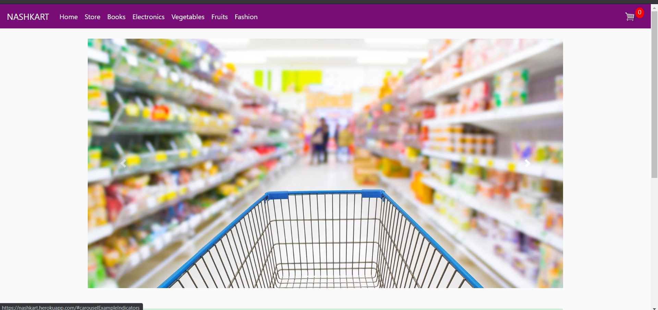

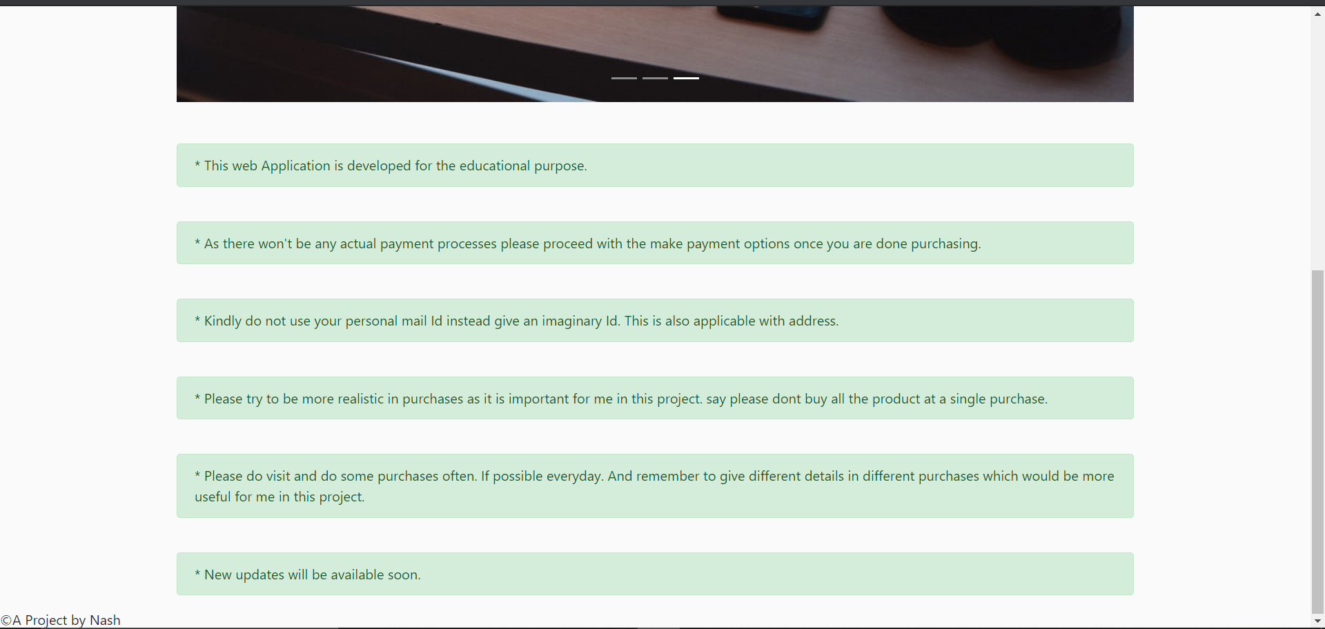

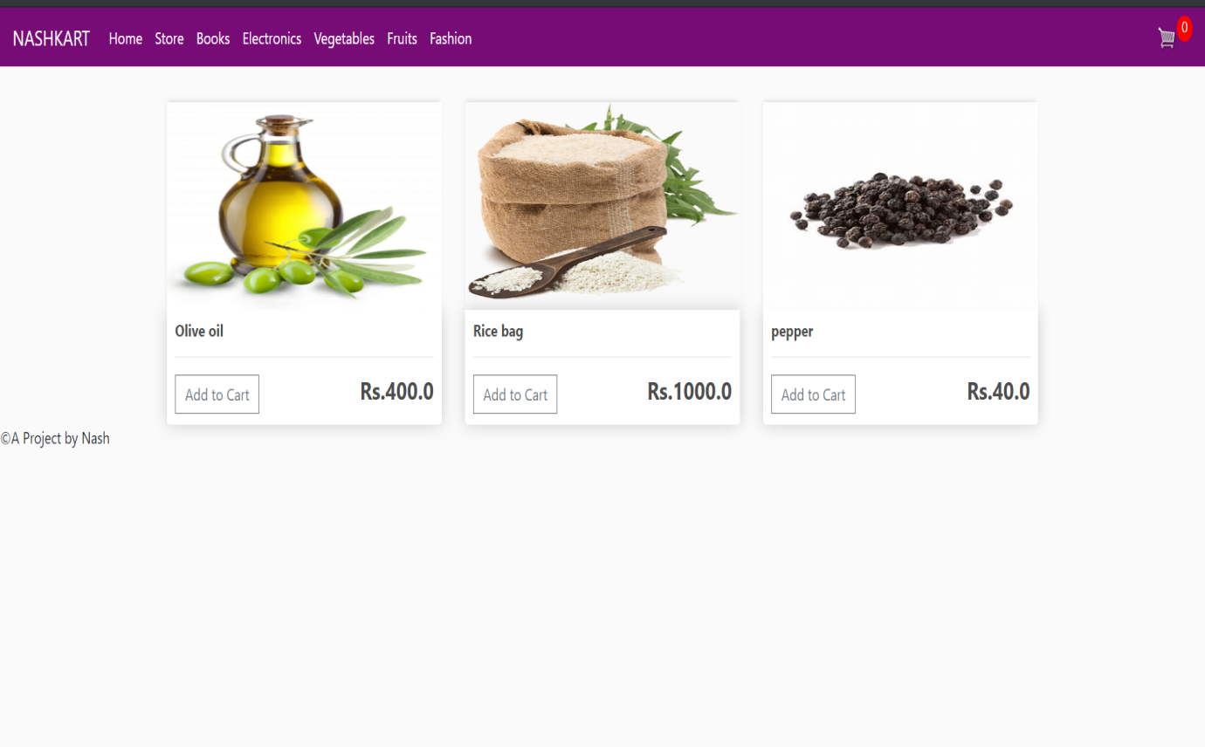

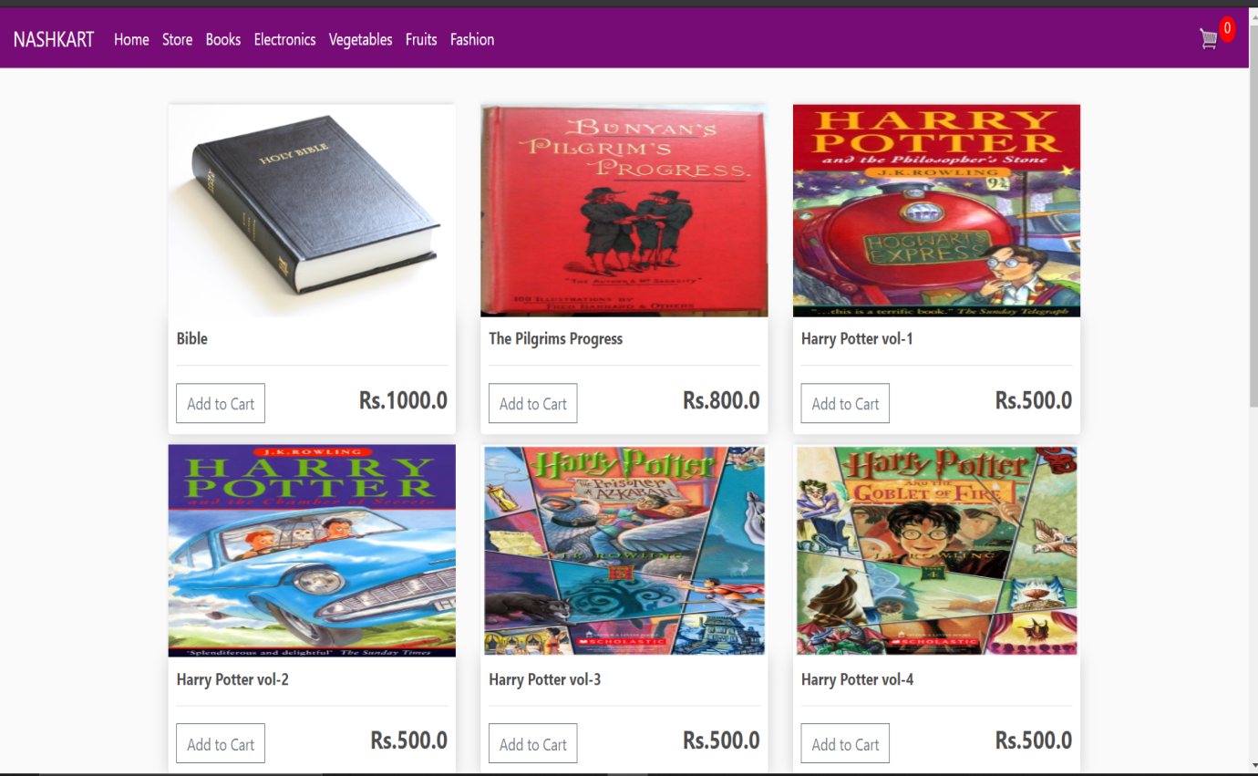

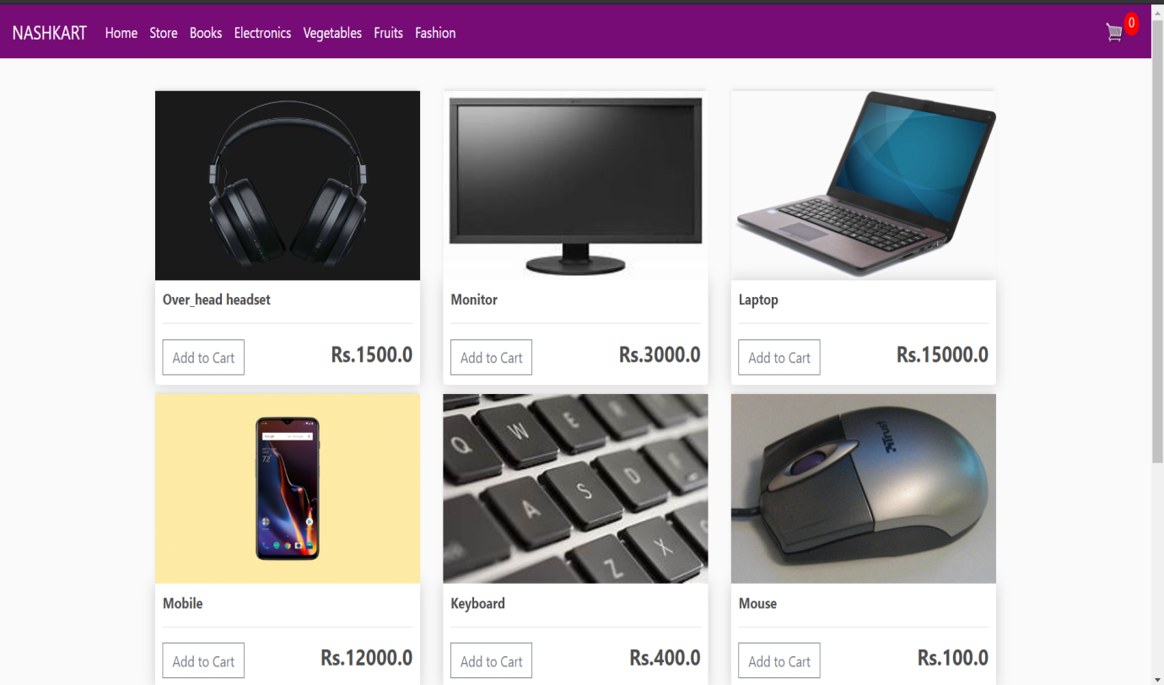

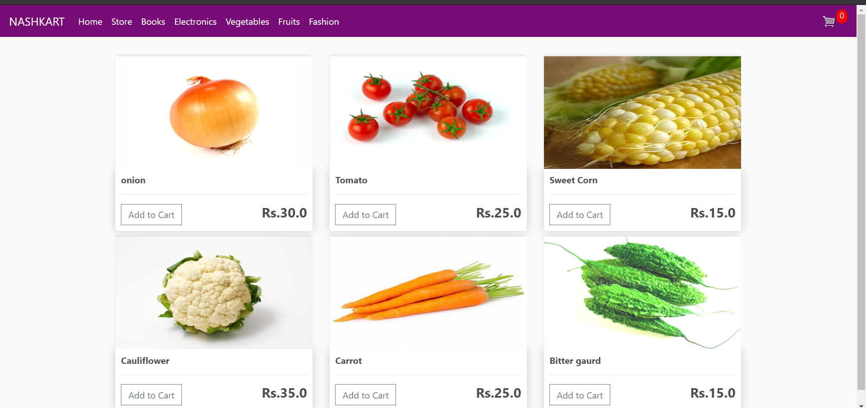

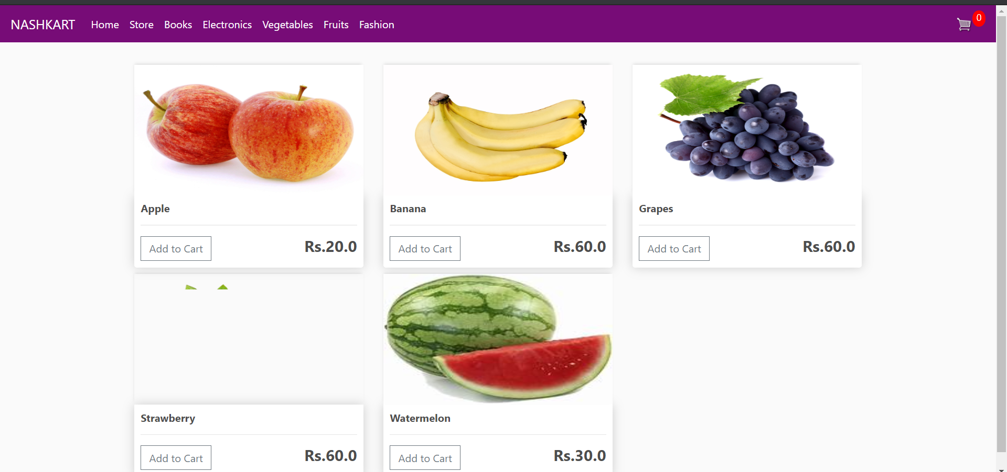

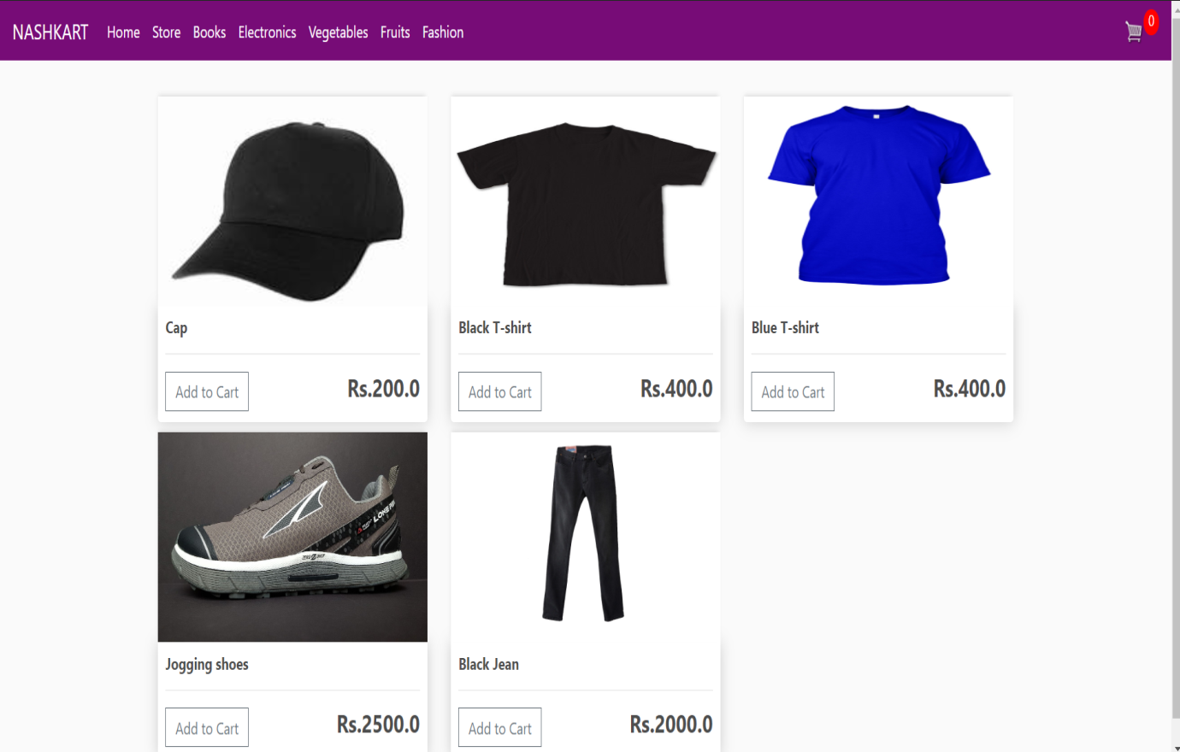

ANALYSIS REPORT:

STATE REPORT:

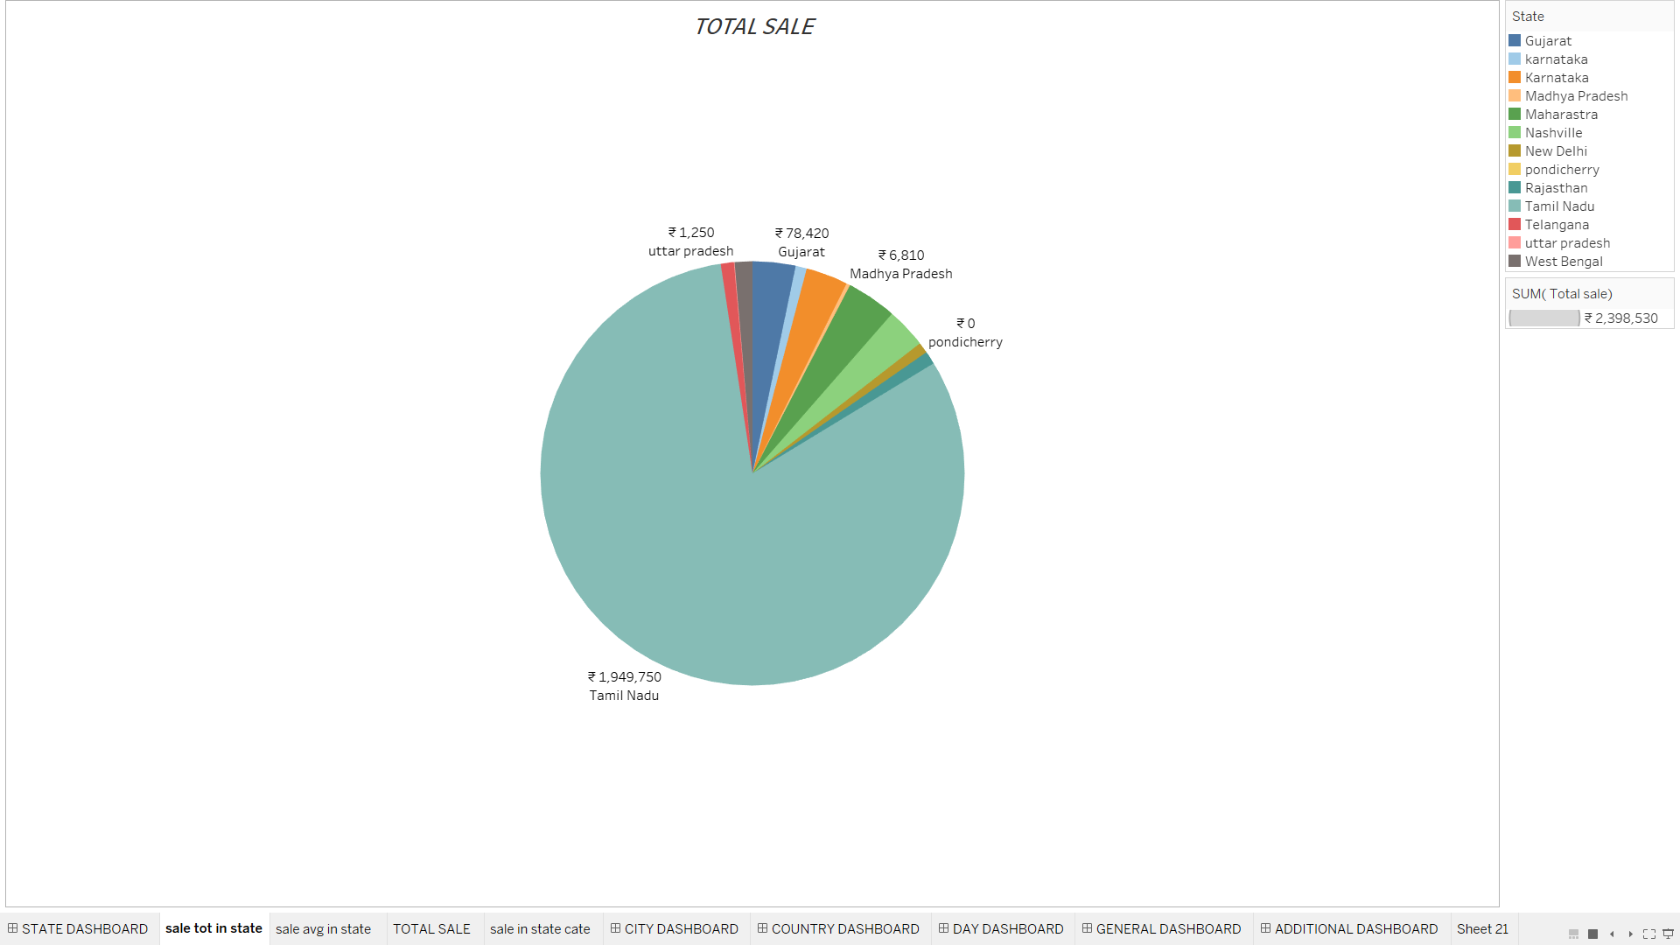

This shows that high amount of sale took place in Tamil Nadu when compared with others.

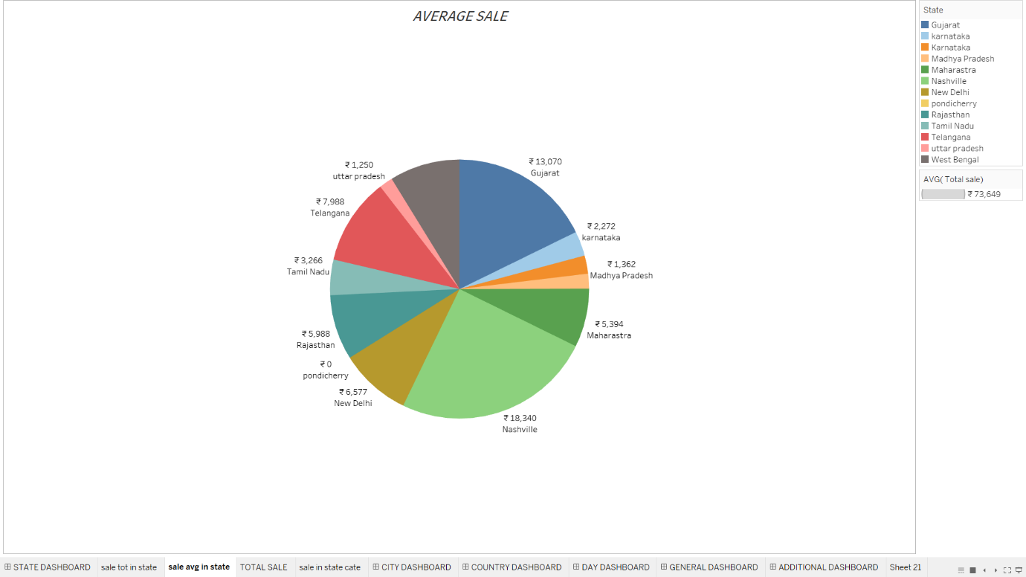

But on an average Nashville is leading in the sale followed by Gujrat and not Tamil Nadu which was in the lead on total sale.

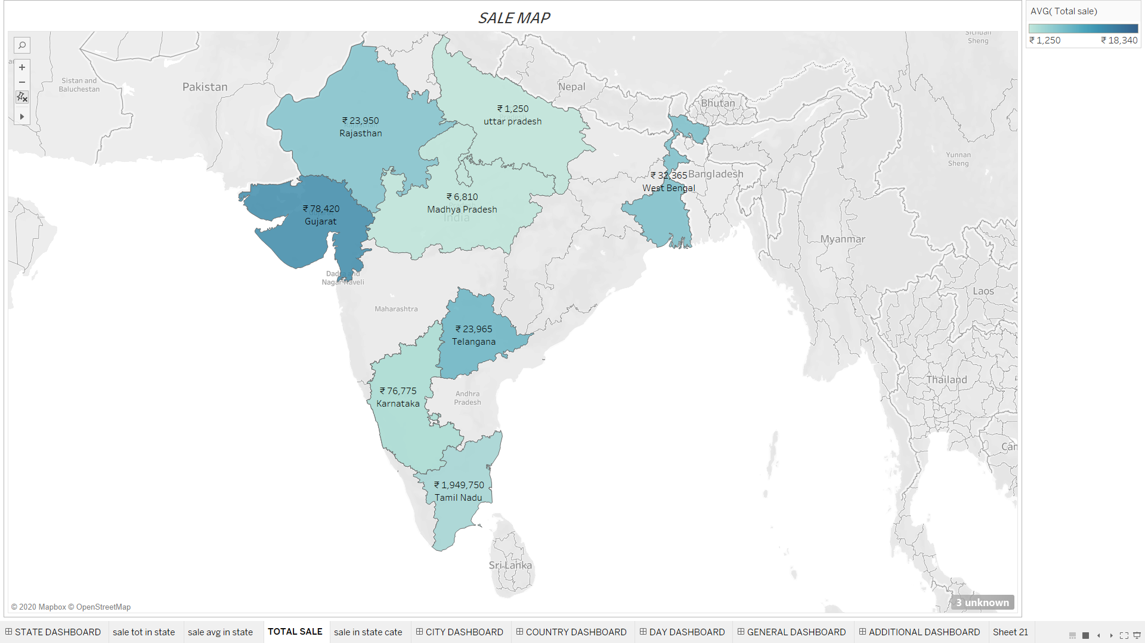

This is a sale comparison graph with the total sale amount and the location in the map.

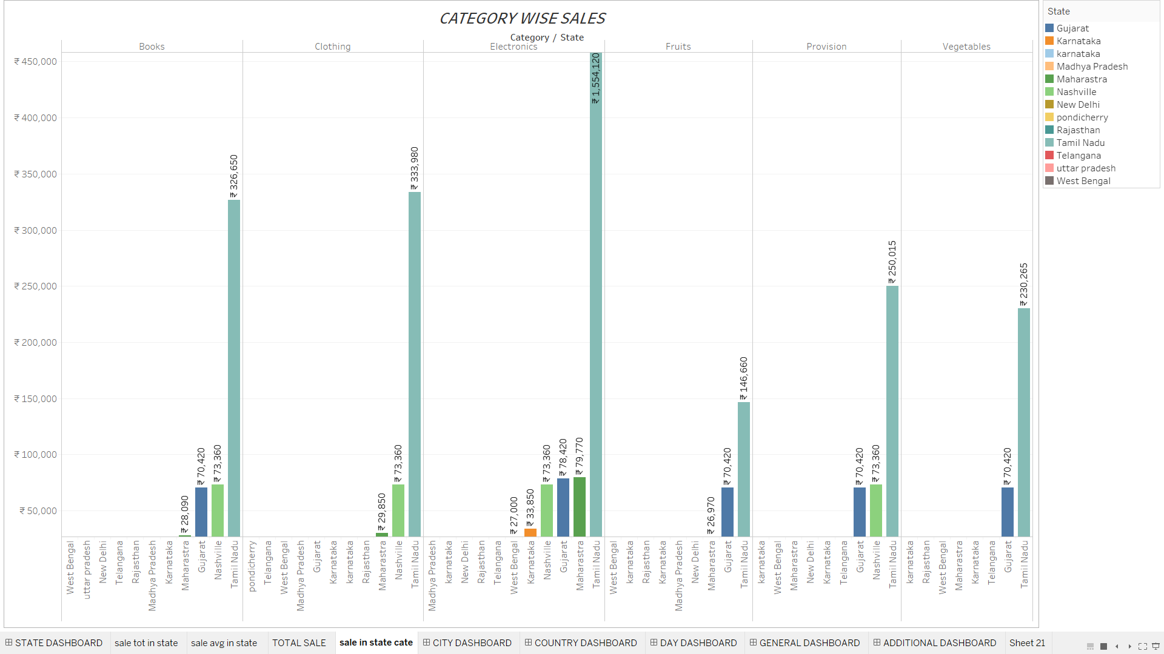

This chart shows the total sale of all category in the state. The highest amount of sale has occurred in electronics category.

COUNTRYWISE ANALYSIS:

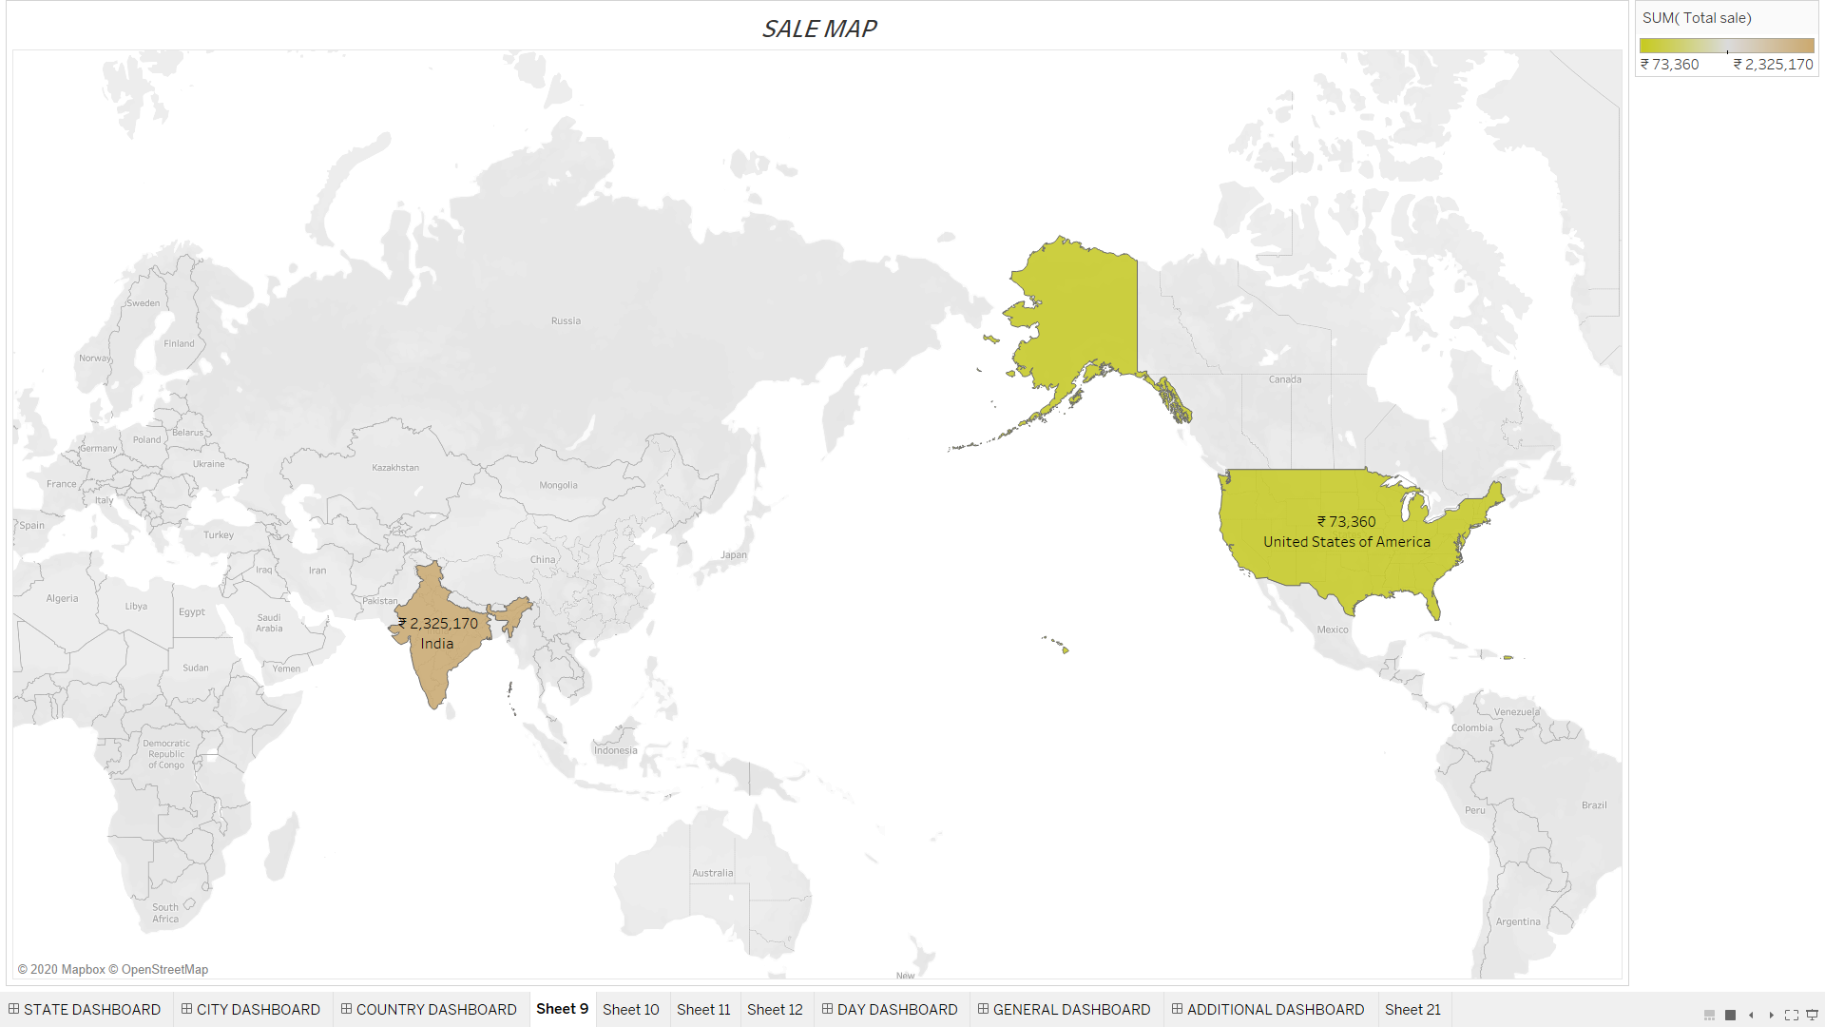

This graph shows the total sale worldwide. In this case two countries were involved in the business.

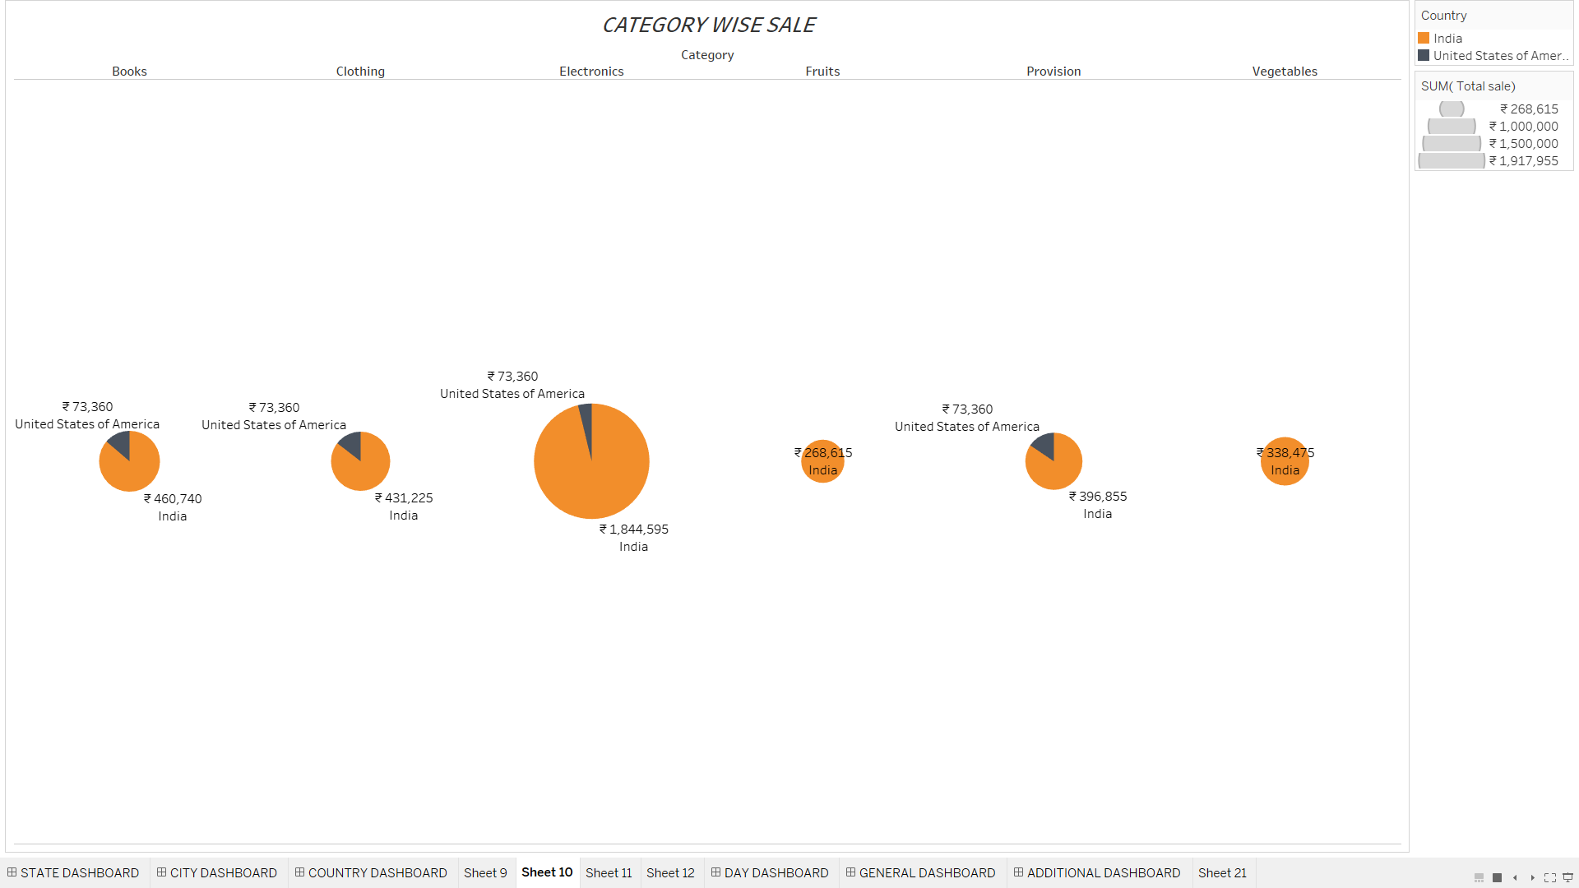

Comparing the sale by category among the countries.

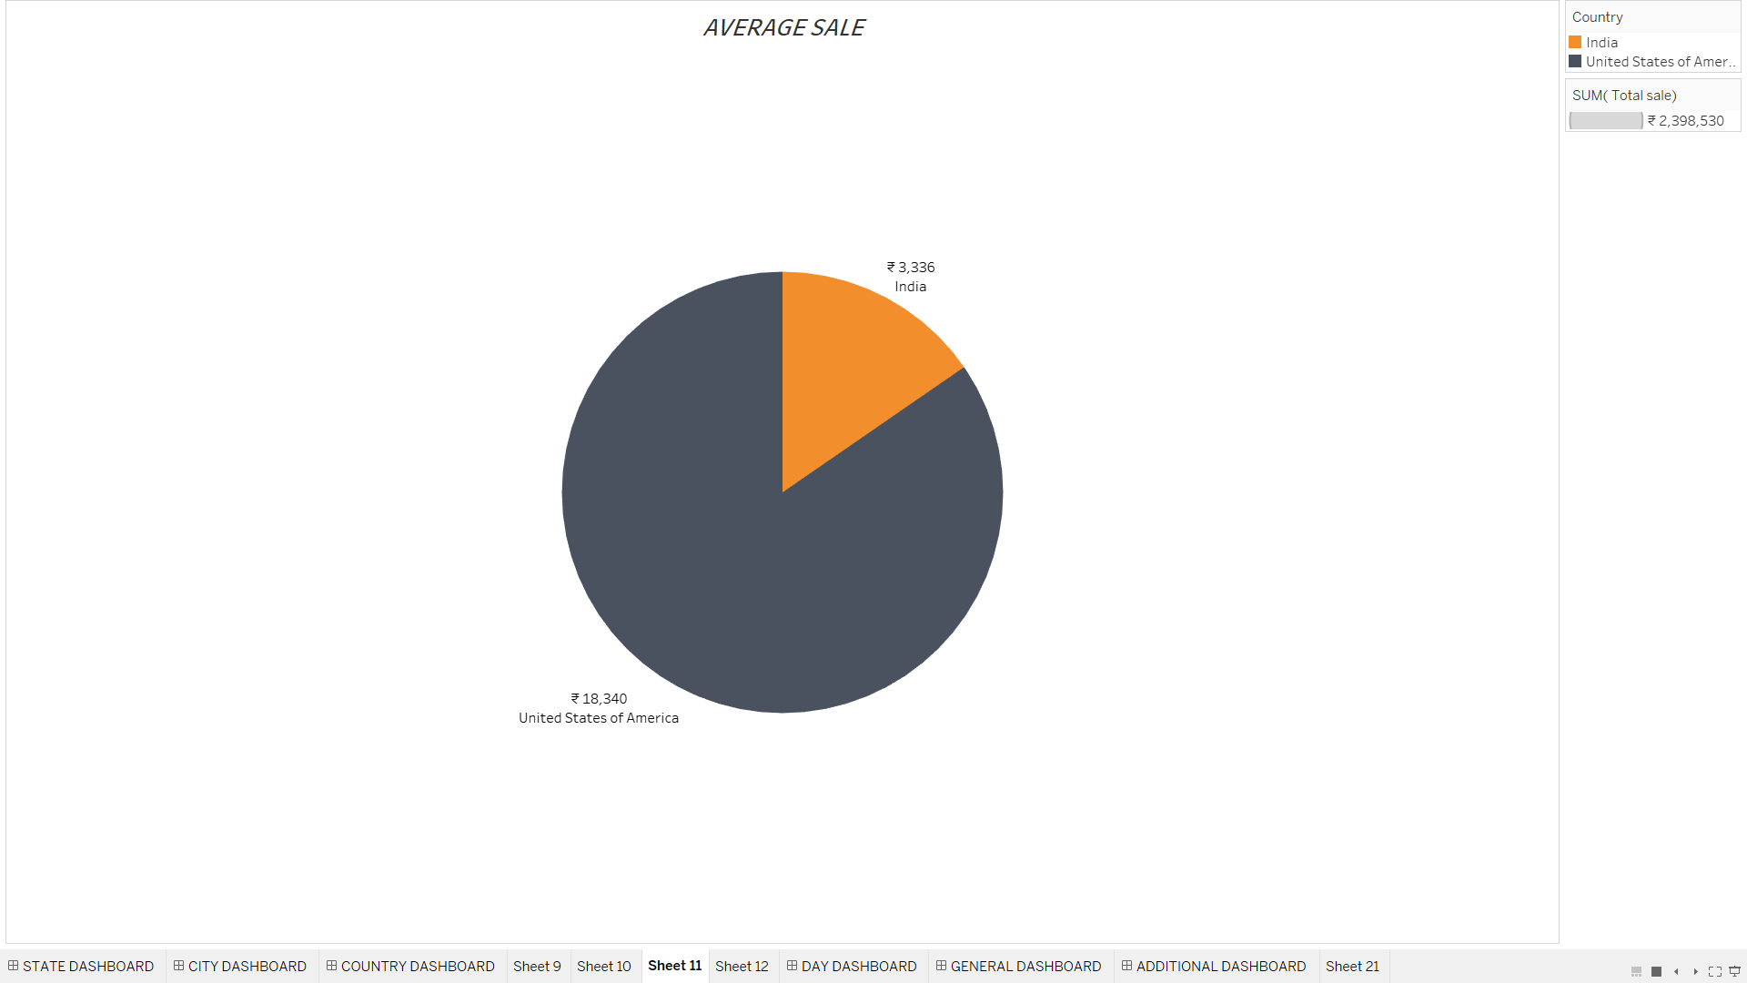

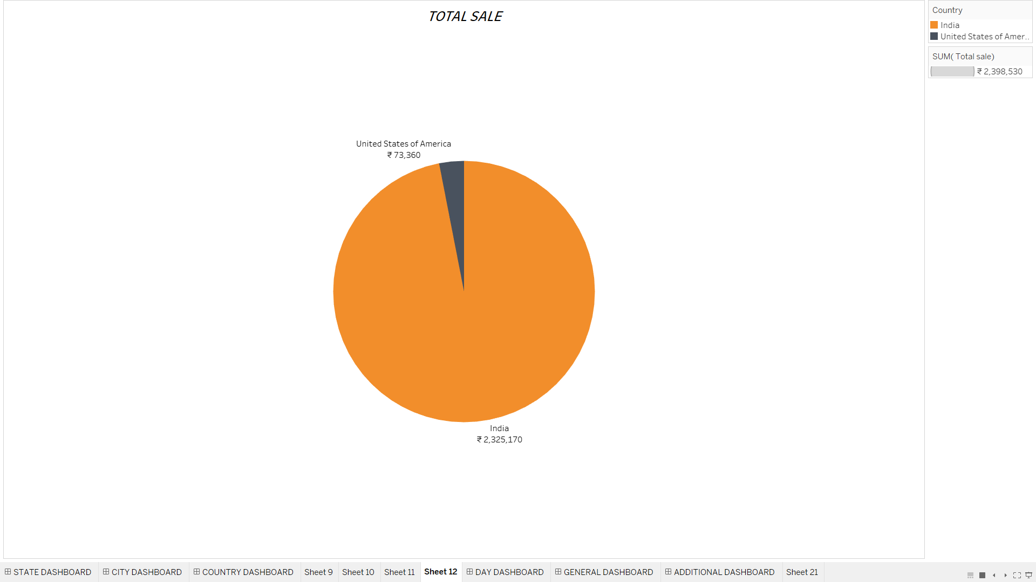

These two pie chart shows average sale and total sale in the countries respectively.

CITY WISE ANALYSIS:

The following two graphs shows the category wise sales and total sales in the cities.

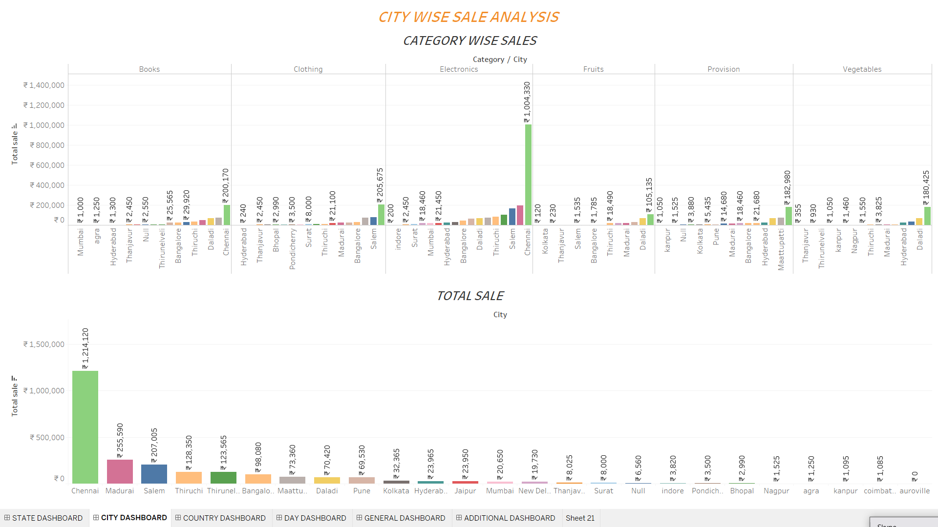

DAY WISE ANALYSIS:

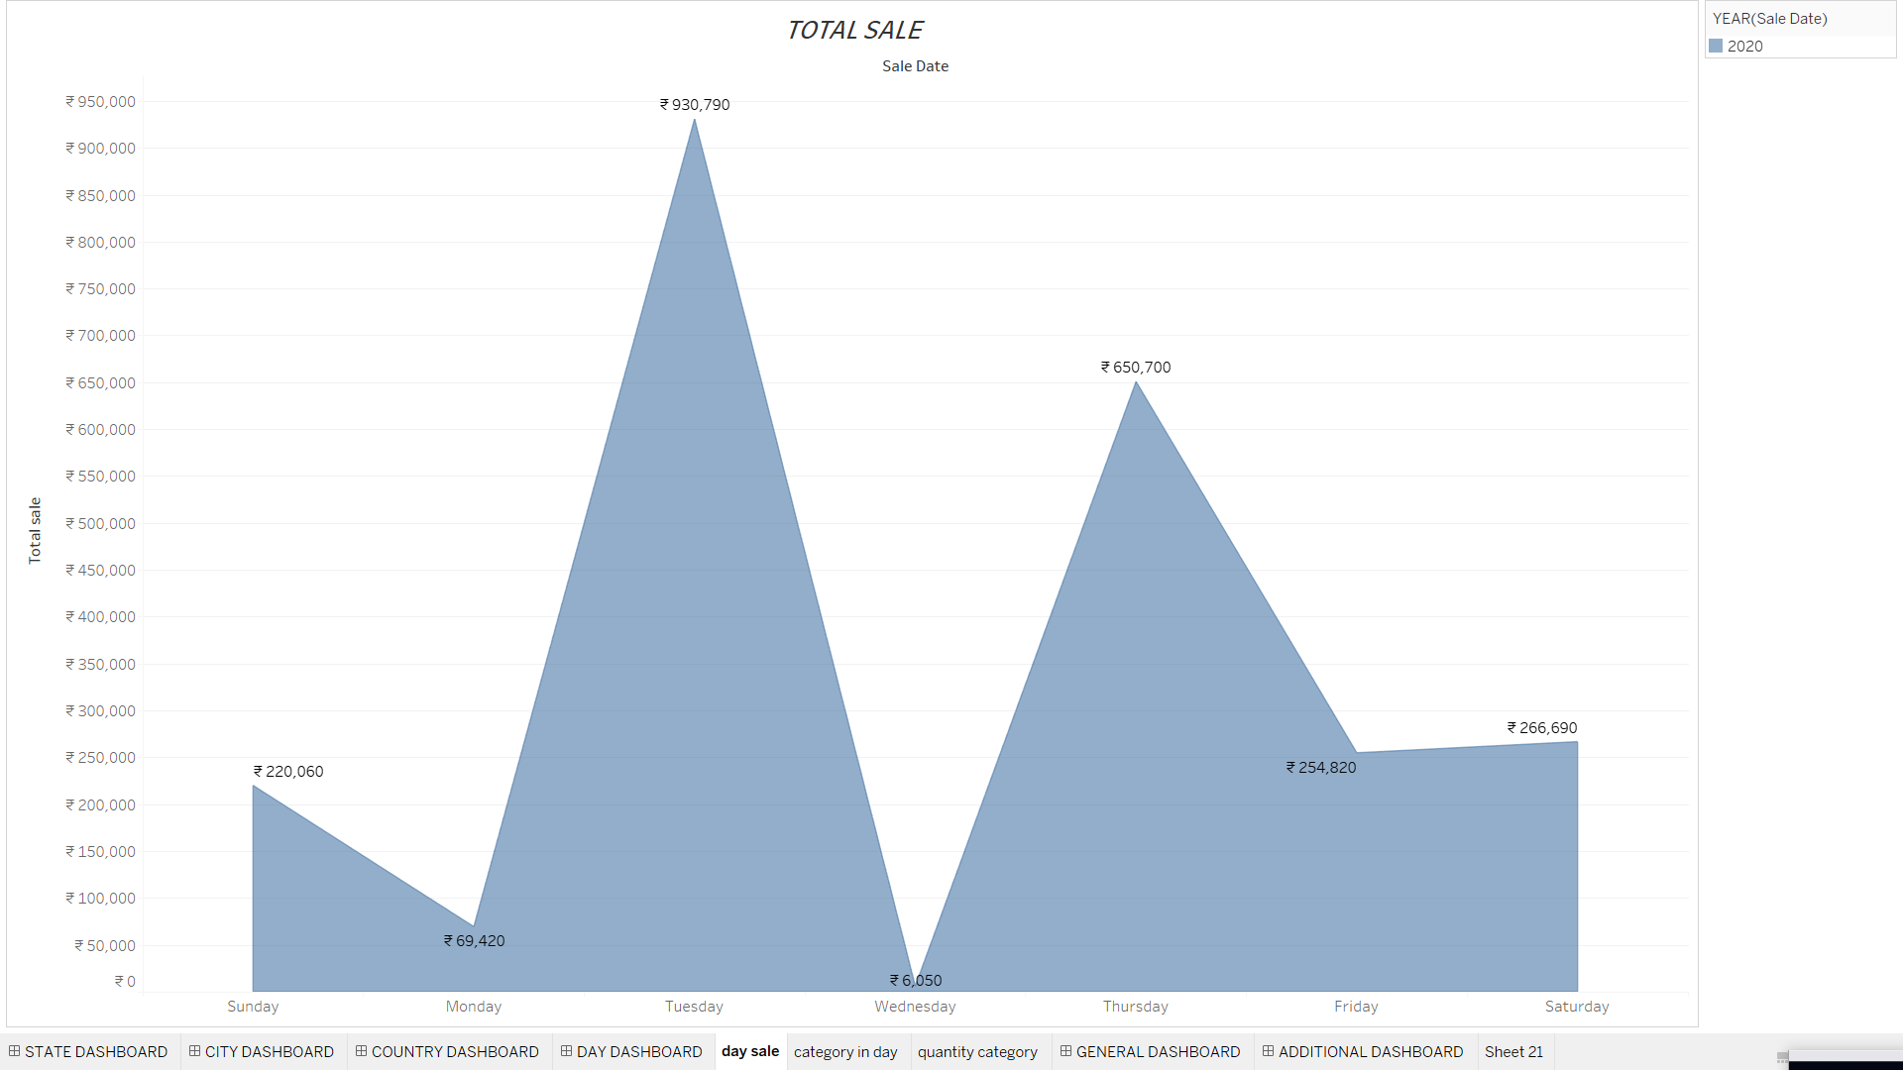

This graph shows the sale peak i.e. in which day the sales occurs the most and in which it occurs less.

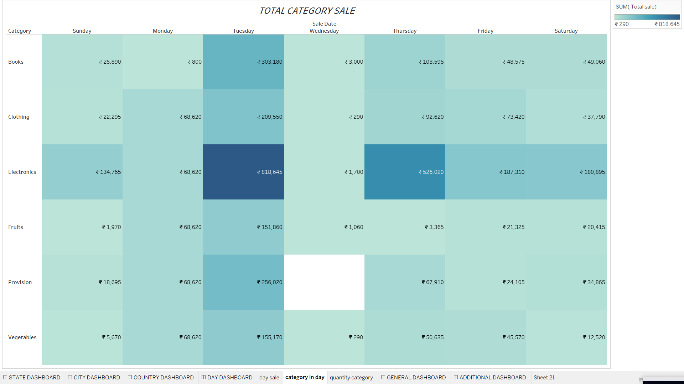

This graph gives the amount details category wise in a heat map format.

DATEWISE ANALYSIS:

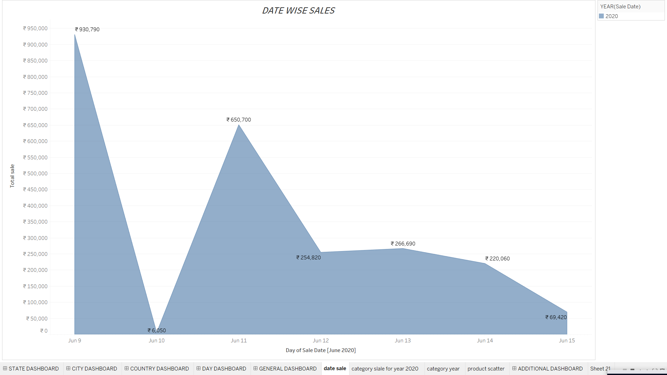

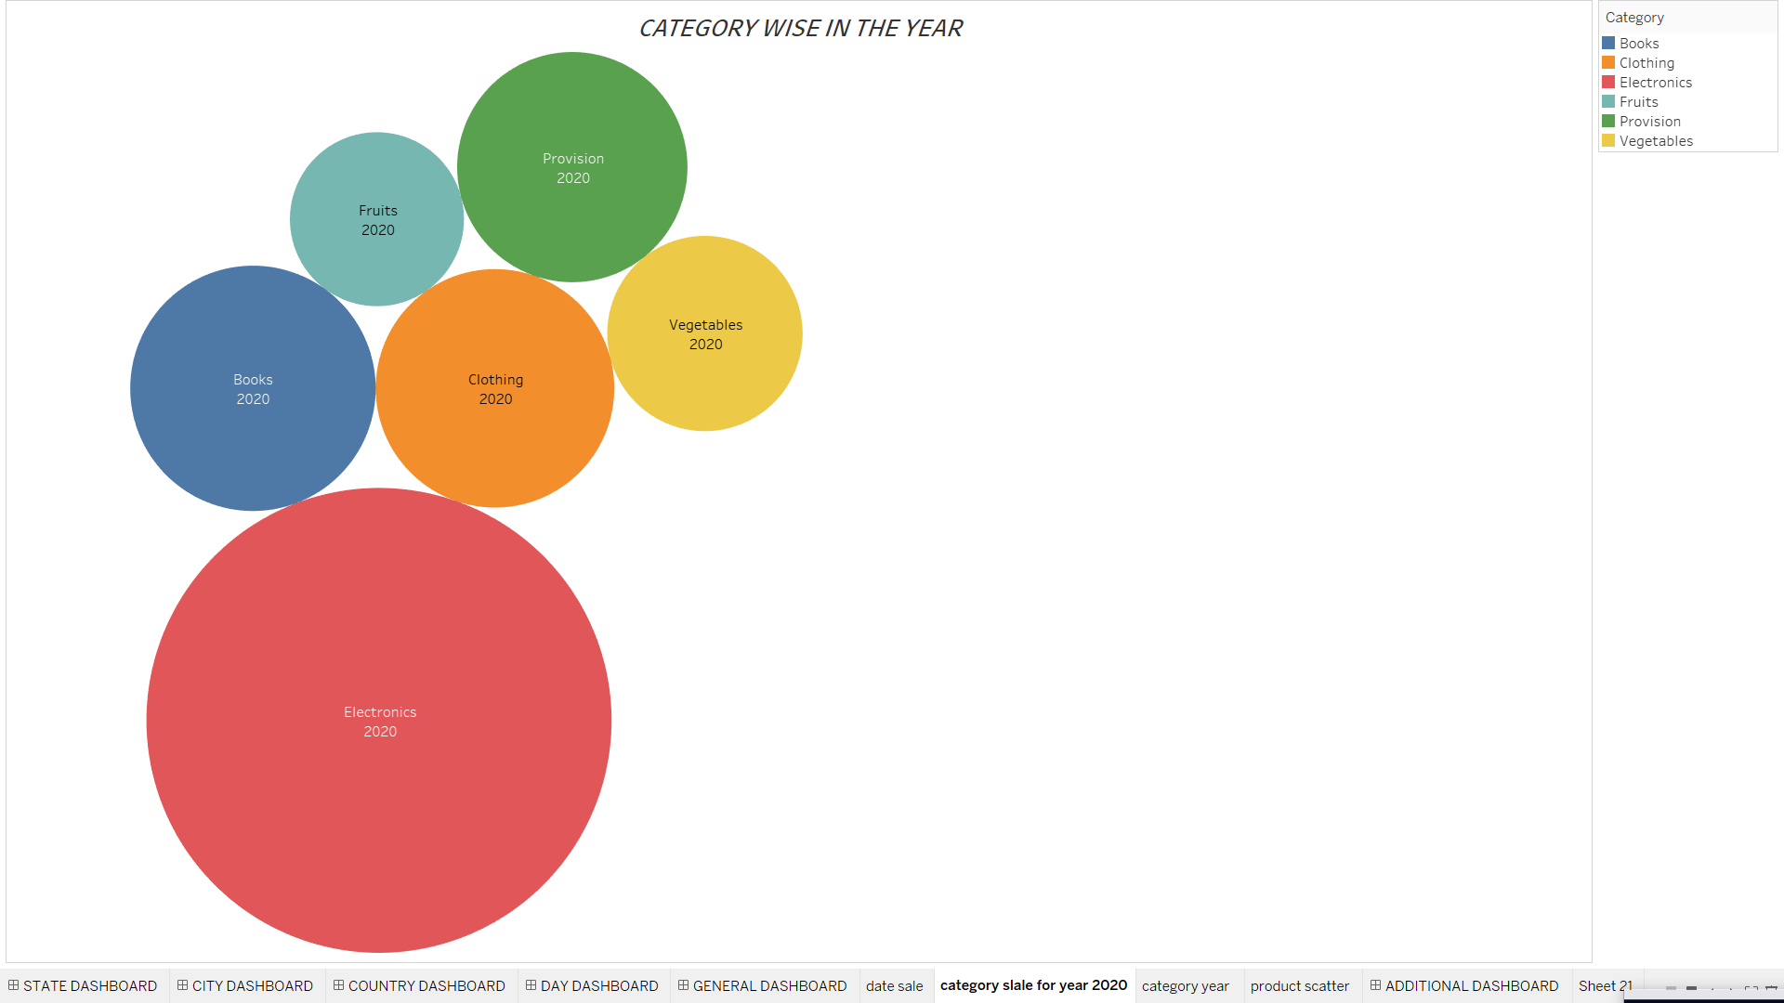

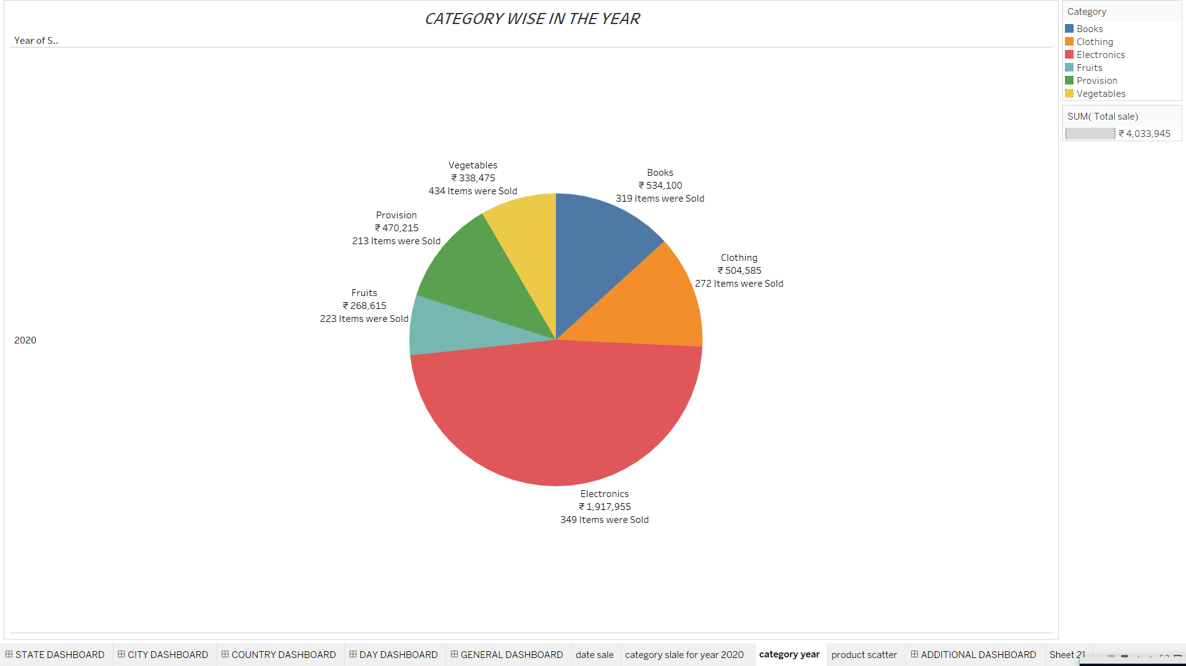 These two charts help us to know about the most sold category over all during a year.

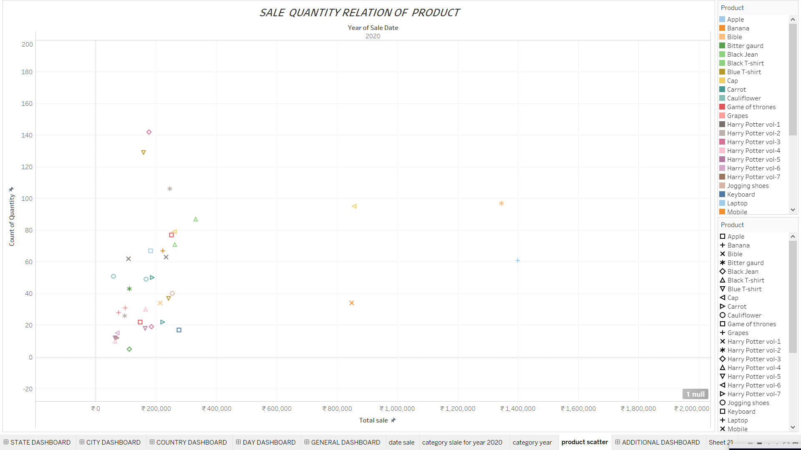

This plot shows the products that have been sold. The total amount and quantity are used to relate this.

GENERAL SALES ANALYSIS:

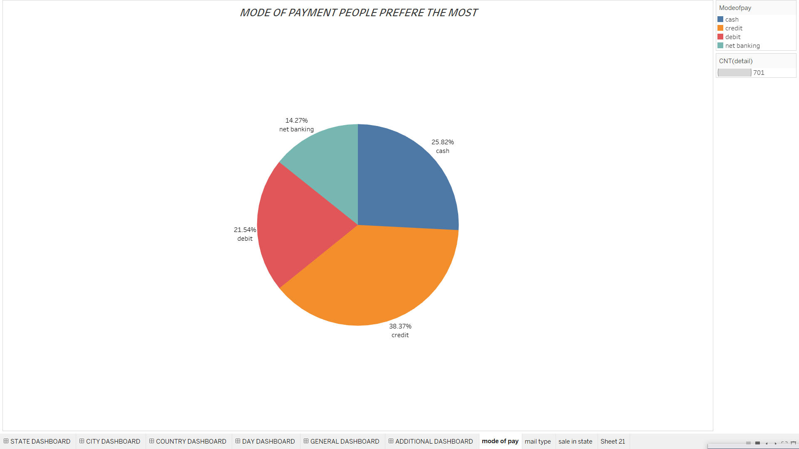

It shows that most people purchase using credit card followed by cash and credit card.

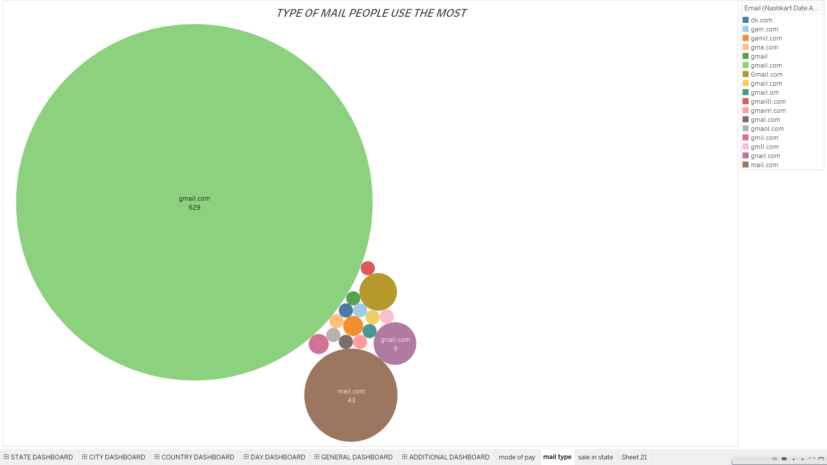

This graph is just to get knowledge of the mail type people use.

By using Tableau interactive dashboards can also be created by combining the charts.

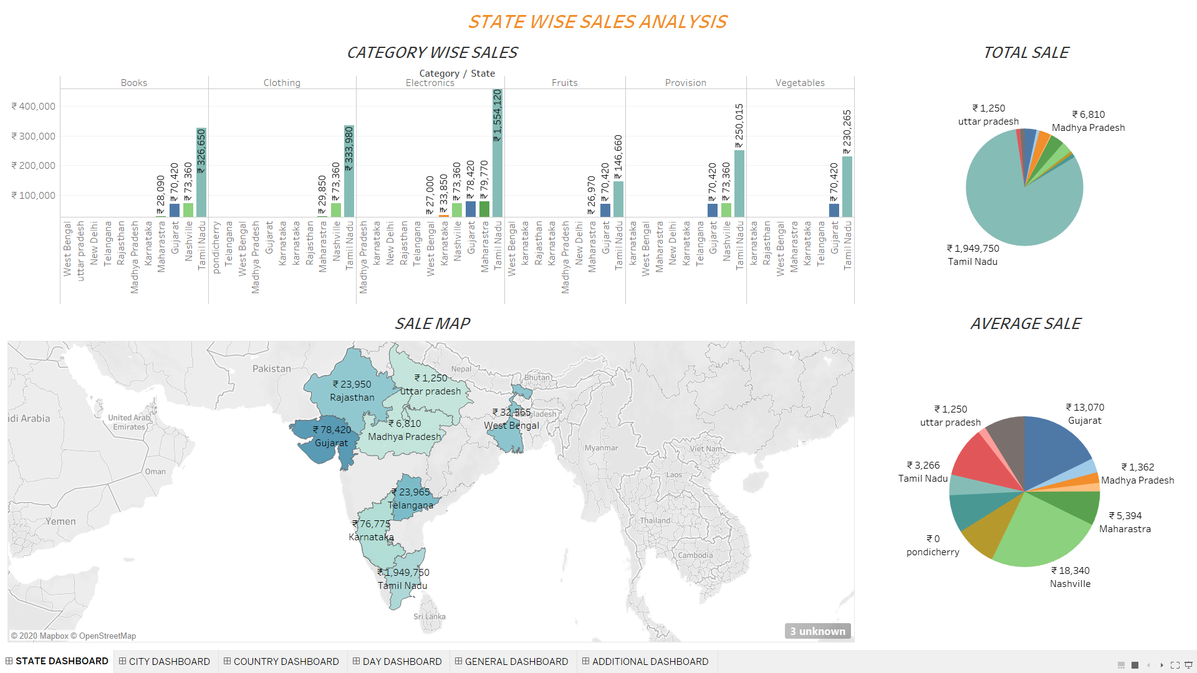

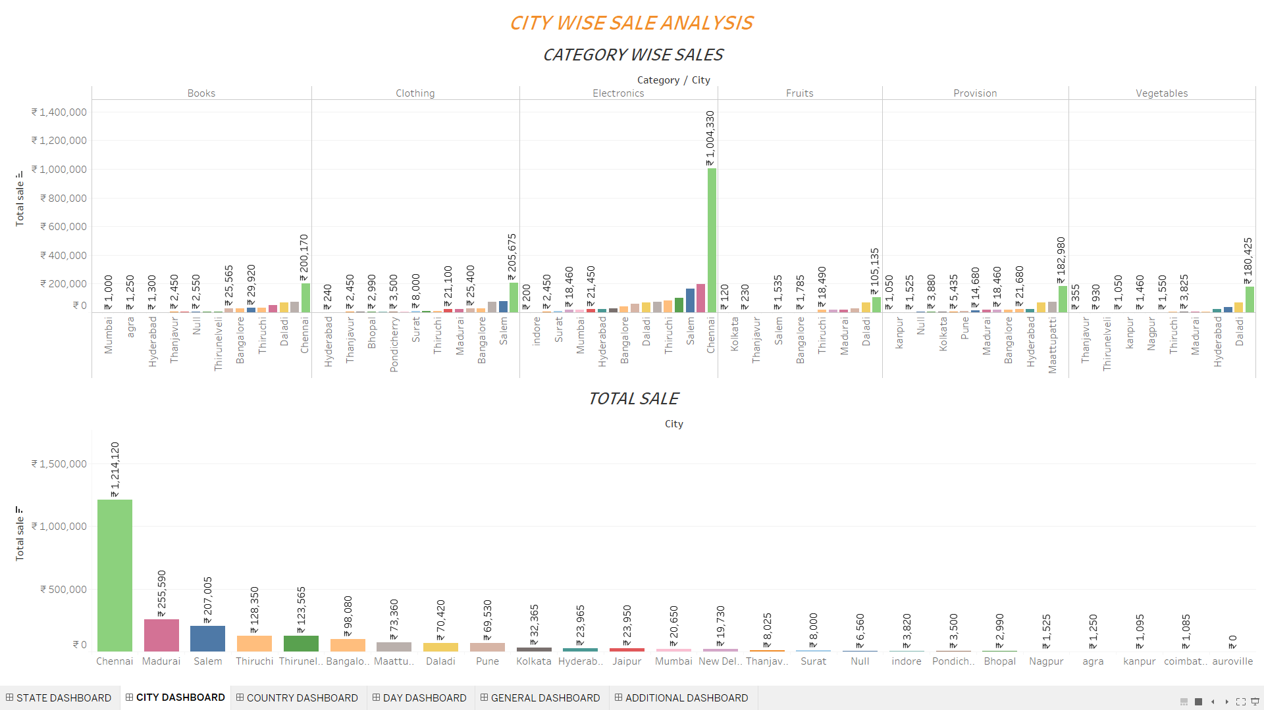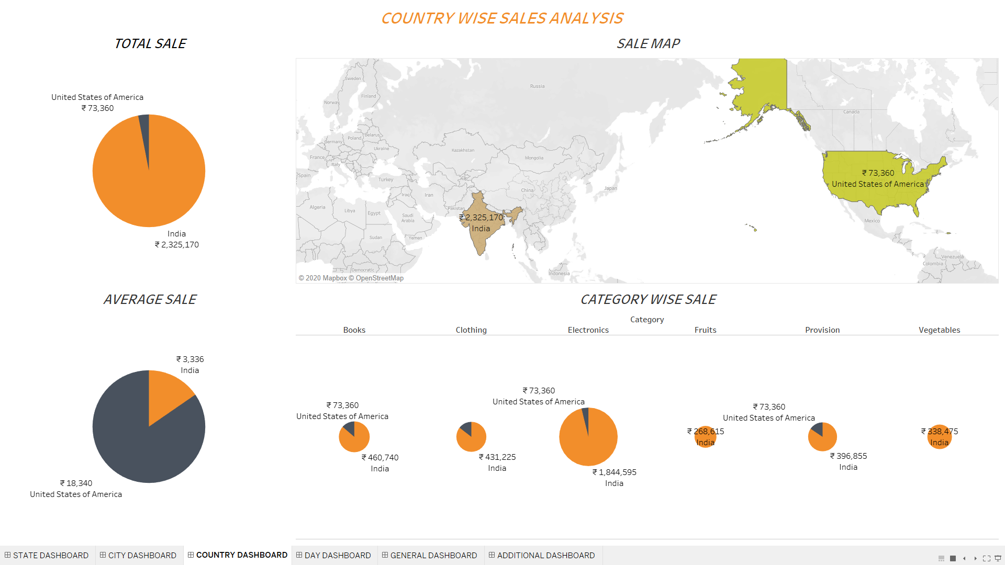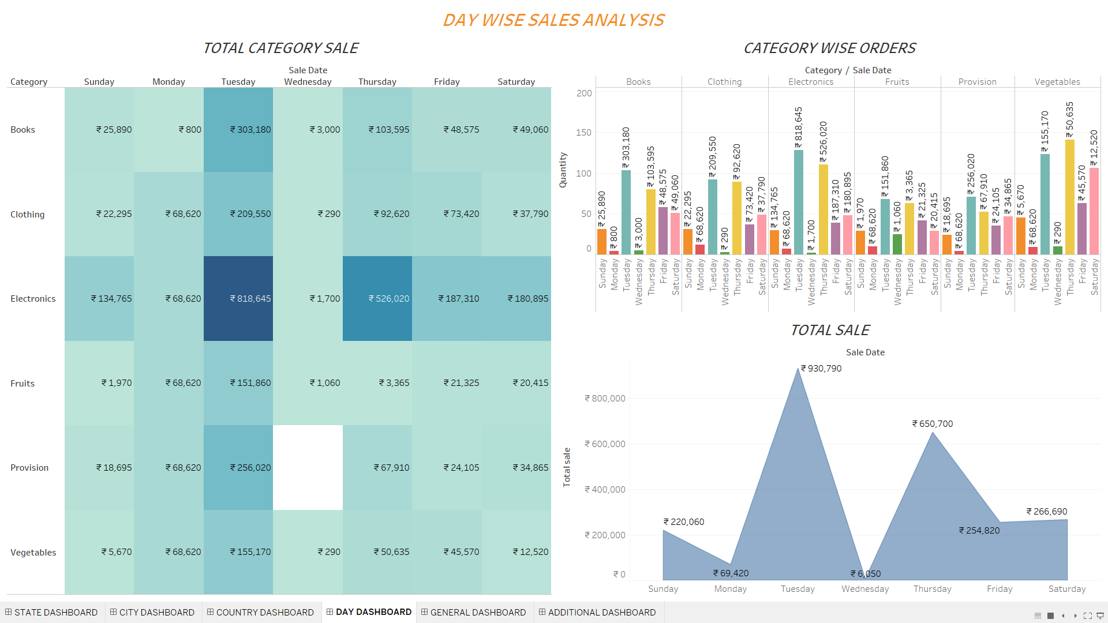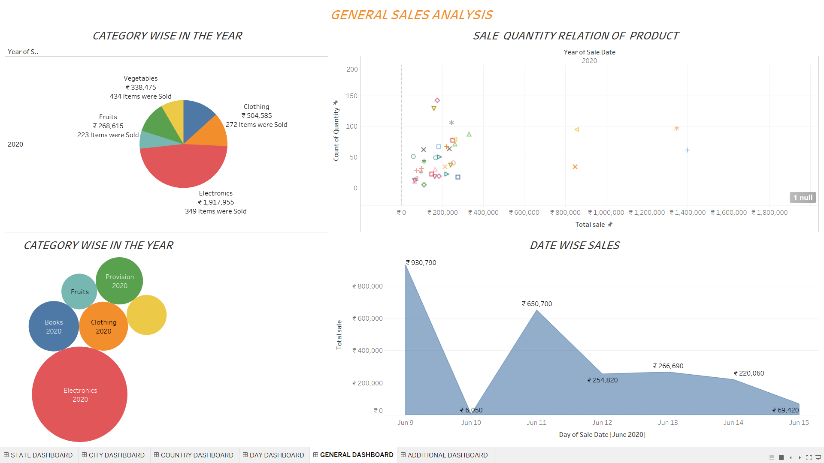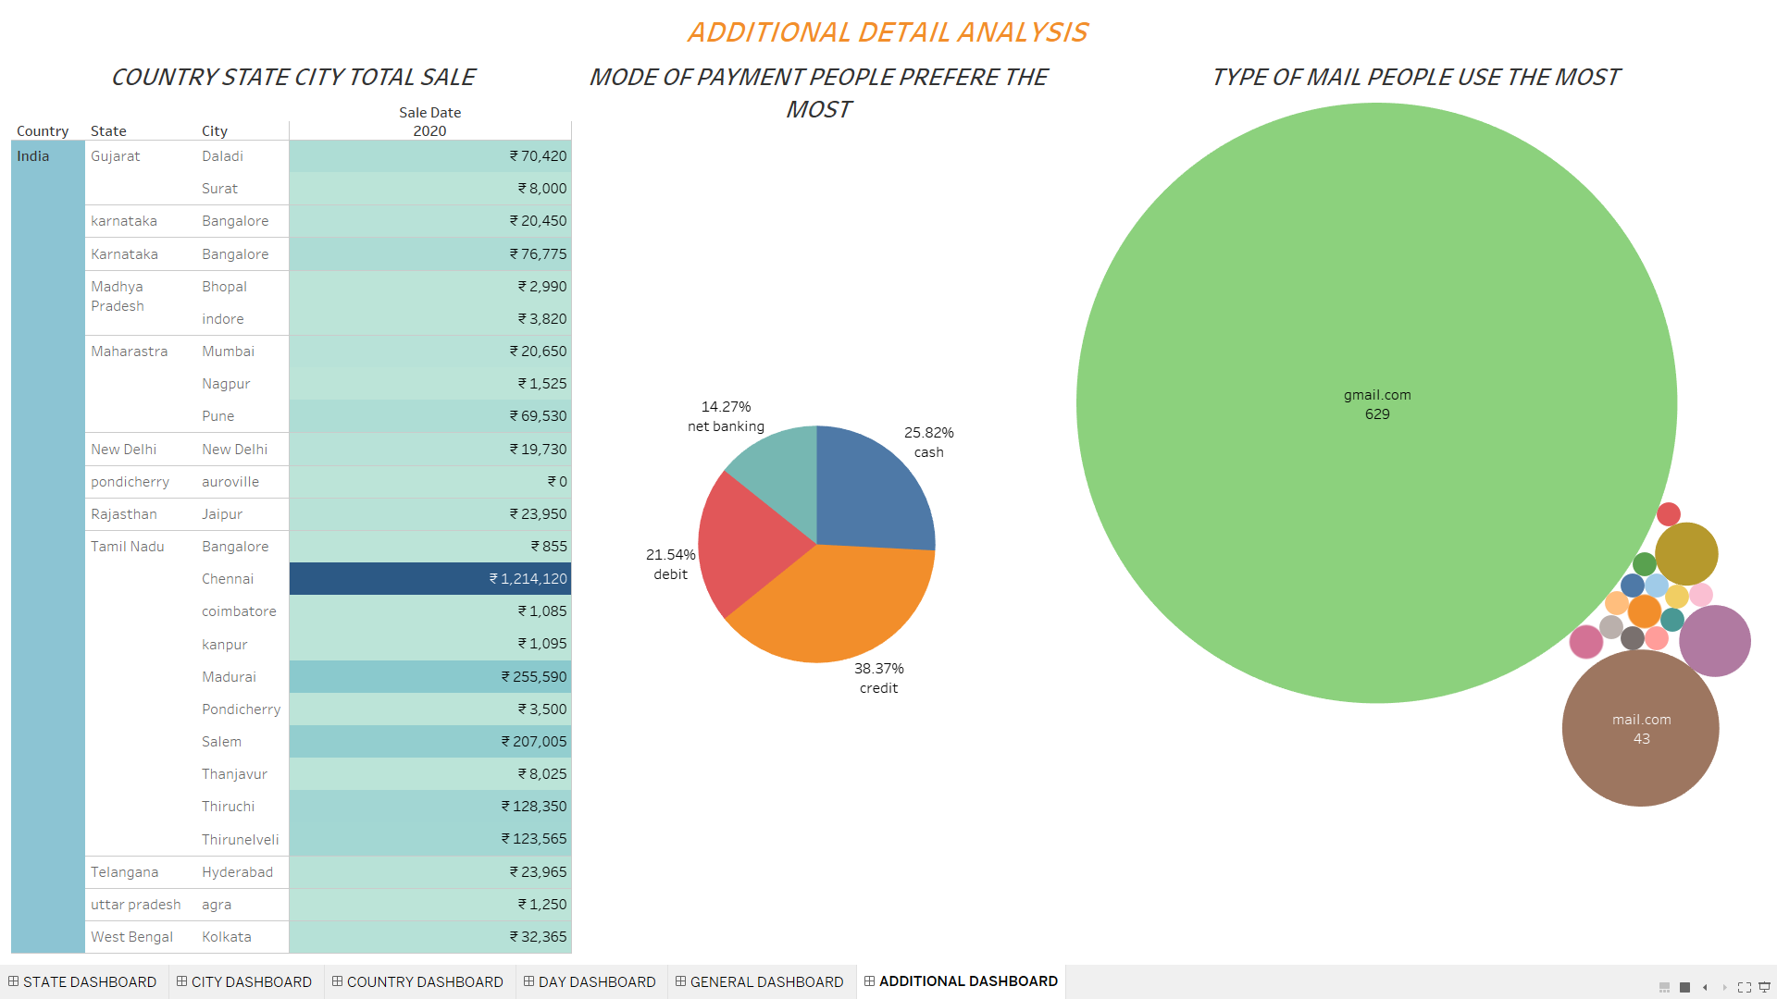

5.CONCLUSION

SUMMARY:

The web application is successfully created and deployed online for the users. The data generated by the web application (NASHKART) through the users are collected and analysed to get the insight for the development of the ecommerce business (NASHKART).

For further reference and source code refer the following link:

<https://nashkart.herokuapp.com/>

<https://public.tableau.com/profile/naresh.kumar.j>

<https://github.com/Nash-git07/Nashkart-Project>

FUTURE WORK:

The web application can further be developed for the users by implementing real transactions and real products for the sale and the web application can be used for a real business scenario. For the analysis part models can be developed and analytics can be done for the future of business.

REFERENCE:

<http://Stackoverflow.com>

<http://Geeksforgeeks.com>

<https://data-flair.training.com>

<http://pandas.documentation.com>

<https://realpython.com>